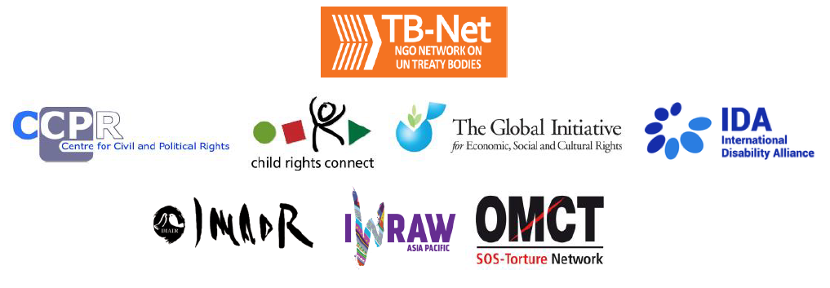

Elections 2022

Committee on the Rights of Persons with Disabilities (CRPD)

Committee on the Elimination of Discrimination Against Women (CEDAW)

Human Rights Committee (HRCttee)

Committee on the Rights of the Child (CRC)

Committee on Economic, Social and Cultural Rights (CESCR)

Subcommittee on Prevention of Torture (SPT)

  - Questionnaire for candidates
Six UN Treaty Bodies (Committee on the Rights of Persons with Disabilities (CRPD), Committee on the Elimination of Discrimination Against Women (CEDAW), Human Rights Committee (HRCttee), Committee on the Rights of the Child (CRC), Committee on Economic, Social and Cultural Rights (CESCR) and Subcommittee on Prevention of Torture (SPT)) will have elections organised in 2022.
In order to strengthen the treaty bodies, the International Disability Alliance, Child Rights Connect, IWRAW Asia-Pacific, the Centre for Civil and Political Rights and the Global Initiative For Economic, Social And Cultural Rights – as part of TB-Net, the NGO network on the UN Treaty Bodies – seek to promote quality, independence and diversity of treaty body membership through transparent and participatory nomination and elections processes.
This questionnaire, which is sent to all nominated candidates and is based on the criteria set forth in the relevant treaties and in the General Assembly Resolution 68/268, will enable all States and other stakeholders to better understand the skills, experiences and motivation of running candidates to CRPD, CEDAW, HRCttee, CRC and CESCR in advance of the elections.
The written responses to the questionnaires will be made available on the website www.untbelections.org, while the video responses will be shared on a dedicated YouTube page.
This initiative does not imply that we support or oppose any individual candidates.

Questions for all treaty bodies candidates

1. Name:
Bragi Guðbrandsson
2. Nationality:
Iceland
3. Current position:
Member of the Committee on the Rights of the Child
4. Are you currently holding, or have you previously held any position on behalf of, or for, your Government (Executive branch) that may compromise your actual or perceived independence and impartiality? If so, please give details:
No

5. Please indicate any current or potential conflict of interest that may prevent you from exercising independence and impartiality in your work as a member of a UN treaty body:
No current nor potential conflict of interest

6. Was the nomination process for your candidacy a transparent and participatory process? Was civil society or other relevant stakeholders involved?
My nomination is supported by the other Nordic countries, i.e. Denmark, Norway, Sweden and Finland. There was consultation done between the Nordic countries before my candidature was given a Nordic support. In the domestic context I had a long-standing career in public office and as a child right activist, including as one of the founders of Save the Children Iceland and on the board of UNICEF National Committee of Iceland.

7. During your possible mandate as a Committee member, what other positions or professional activities do you intend to engage in?
I am an Honorary founding member of the Promise project promoting the Barnahus model in Europe and beyond (see: barnahus.eu). Currently this may involve presenting and participating in regional and international events on child abuse, including sexual abuse and exploitation on a pro bono basis.

8. The commitments as a Committee member are very time-consuming during and outside session time. How will you ensure to have the capacity to dedicate the necessary time to the work of the Committee, both in person and online?
I have no other engagements or work obligations than to serve the Committee as I have done since I became a member in 2019.

9. What are the current and main challenges that you see for the treaty body system and what are your ideas for improvement?
Today, the Committee’s main challenge is to address the unacceptably long backlog of state reports by implementing the simplified reporting procedure as a default work procedure and ensure the predictable calendar (8 years) with a midterm follow up. Furthermore, there is much room for improving the coordination of the work of the treaty body system with the aim of harmonizing, avoiding duplication and to increase efficiency should be high on the agenda.

10. Given the current situation of the COVID-19 pandemic worldwide and the disruption of in person meetings of treaty bodies, will you be willing to adapt to undertake online work during your mandate, as an increasing way of functioning of the Committees?
Online work has been necessary during the pandemic, where I have actively participated, including in the four Committee sessions which have been held online and as well with regard to working group meetings of OPIC cases, the making of GC 25 and GC 26, the preparation of the DGD (Day of General Discussion) and other working groups of the Committee. However, I am of the opinion that State party reviews should be face to face as possible or in hybrid format. The experience of fully online state reviews is regrettably very poor, not least due to the fact that it is less inclusive due to different time zone and connectivity problems.

Link to your full resume: CV-Bragi-Gudbrandsson.docx

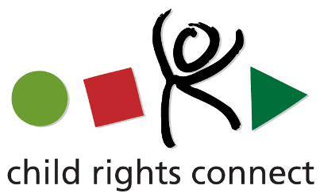

Questions for candidates to the UN Committee on the Rights of the Child (CRC)
Please provide responses that are as precise as possible and in no more than 200 words per question.

1.What motivates you to be a member of the Committee on the Rights of the Child? (video option)
Soon after I graduated from University, I started to work with vulnerable children and families as I director of local social services. After a decade, I joined the Ministry for Social Affairs to work on legal reforms in the interest of the child for 5 years. Then I was appointed Director General of the Government Agency for Child Protection for over 20 years. That position gave me the possibility to engage in regional and international work, including for Council of the Baltic Sea States and the Council of Europe for over 20 years. Therefore, my professional dedication has been to heighten children’s rights locally, nationally, regionally and globally as the member of CRC. As one of the founding members of Save the Children Iceland as well as member of the National Committee of UNICEF I have also been a child activist.
Becoming a member of the Committee is a direct continuation of the fact that I have devoted my professional and personal life to children

2. Taking into account the current composition and expertise of the Committee, what would be your added value? (video option)
My added value has mainly been with regards to violence against children, in particular sexual abuse and sexual exploitation. I am the founder of Barnahus in Iceland, the child-friendly and multiagency framework which aim is inter alia to balance the human rights principles of the “due process” and the “best interest” of the child. I have devoted my professional and personal energy to promote this model in Europe and beyond. The proliferation of Barnahus in Europe to approximately 25 states as well as the impact it has had on European law, such as the CoE instruments (the Lanzarote Convention, the Guidelines of Child-friendly justice) has been added value to the jurisprudence of the CRC.
In addition to the above it should be stated that I have a long-standing experience in “operationalizing” the Convention in different context such as in terms of alternative care, positive parenting, child-friendly justice (children as victims, witnesses and in conflict with the law), treatment services for child victims, children with substance abuse and children with challenging behaviours etc. I also have experience in terms of the application of Hague Convention 1980 and children in migration, refugee children including unaccompanied minors.
3. What do you think are the emerging issues and challenges in the implementation of the CRC and its Optional Protocols on a global scale as well as in your country/region?
The climate crisis, loss of biological diversity, pollution, i.e. the environmental issues are currently the most pressing issues globally. The diverse situation of children of the world makes it difficult to rank emerging challenges. The following should be seen as only few of these challenges:
- the long-term impacts of COVID-19 such as the rupture in children’s education, child mental health issues including the consequences of domestic violence and abuse;
- malnutrition, esp. in Africa where there is the fastest growing number of children in the world;
- evidence of increasing online sexual abuse, exploitation and bullying;
- child marriages and child labour in some regions
- listening to children’s voices and child participation, and the protection of child rights defenders;
- the child’s right to an identity;
- discrimination against minorities;
- increased awareness of adverse generational impacts of armed conflicts on children due to the atrocities in Ukraine, Afghanistan, Myanmar, and Yemen to mention only few.
Increased ratifications of OPIC are crucial as there are only 48 states that have ratified and the backlog of reports of the other optional protocols are worrying.

4. What do you think are the areas where the Committee needs to strengthen international child rights standards?
In line with SDG Goal 16, target 16.2 to end all forms of violence against children, there are many challenges. Perhaps my main contribution to the jurisprudence of the Committee in this respect concerns child abuse, in particular child sexual abuse coupled with child friendly justice.
I believe that an end must be put to the practice to have children testify in courts and be subjected to often hostile and intimidating cross-examinations. Repetitive interviews in non-friendly environments, such as police stations, results in secondary victimisation for the child and is harmful for the criminal investigations.
The long duration of time from disclosure of the abuse to the end of the judicial process can be measured in years and has adverse effect on the child who receives paradoxical messages: forget the abusive experience and continue with your life – but at the same time never forget as you need to remember every detail for the testimony in the courtroom.
Of course, children´s rights cuts across all the SDG goals and there are many additional areas which require stronger and more articulated child rights.

5. How do you envision the work of the Committee in the achievement of the Sustainable Development Goals?
The most effective work of the Committee regarding to the implementation of the SDGs, in particular Goal 16 to promote peace, justice and strong institutions, and it´s specific targets, is to ensure tailored made recommendations in the State Reviews and Concluding Observations.
The jurisprudence of the Committee is the strongest instrument that the Committee can develop albeit other normative work, including general comments in specific areas can have great impact such as the GC24 on Child Justice and GC25 on the Rights of the Child in the Digital Environment, as well as the GC26 on the environment which in the making in line with SDG 13.

6. How do you think the Committee could advance the standards and practices on child participation, and particularly children’s right to participate in political life and child human rights defenders?
The jurisprudence of the monitoring activities and guidance to state parties regarding the relevant article of the Convention 12 to 17, promote these civile rights in dialogues with state parties and stakeholders including by sharing good practices.
Importantly, the Committee needs to be role model for child participation by respecting and further develop its own guidelines of child participation and for the state parties to the Convention. An example of this could be to set guidelines to ensure child participation in the making of general comments and guidelines for state parties for child participation in the preparation of the sate reports to the Committee in line with the existing guidelines of the Committee for child participation. Finally, I should mention that students in the advance studies in international child rights at the University of Leiden have piloted child-friendly versions of some OPIC cases in collaboration with Child Rights Connect. This wonderful work was introduced to the Committee recently. It demonstrated that this is a path worth travel to promote and ensure the important rights of the child embodied in the OPIC.

7. What can the Committee do to further strengthen its engagement with civil society?
The Committee currently plays a great importance to civil society organization in all areas of its work. The contributions of CSOs to the state reviews are pivotal in the monitoring and guidance to state parties. The CRC has decided to introduce the simplified reporting as a default procedure. This requires even closer collaboration and engagement with CSOs in the future as their importance in setting the scene for state reviews becomes of paramount interest.
The Committee has engaged with CSOs in physical meetings in Geneva as well as in online meeting. We have learned the lesson during the COVID-19 pandemic that online consultation is extremely efficient and accessible in most cases, an particularly on a regional basis. Bearing in mind the regional composition of the Committee a more systemic consultation with civil society on regional basis should be considered.

