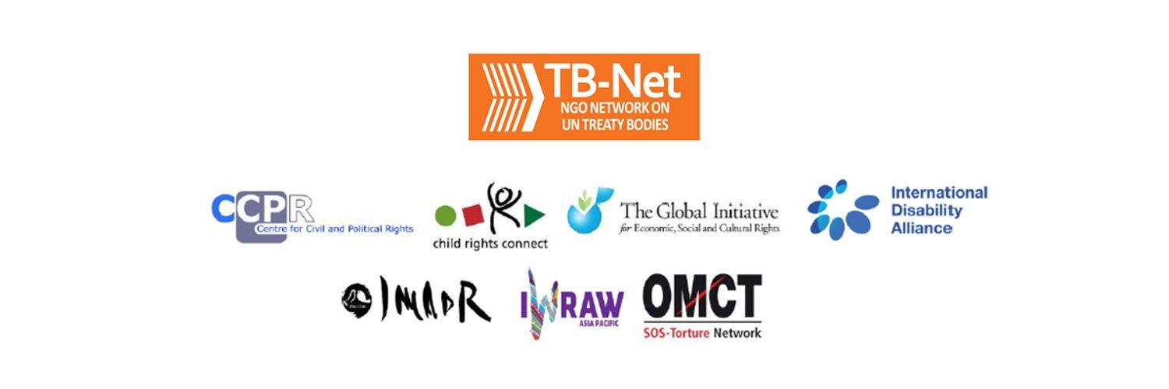

Elections 2020

Committee on the Rights of Persons with Disabilities (CRPD)

Committee on the Elimination of Discrimination Against Women (CEDAW)

Human Rights Committee (HRCttee)

Committee on the Rights of the Child (CRC)

Questionnaire for candidates
Four UN Treaty Bodies (Committee on the Rights of Persons with Disabilities (CRPD), Committee on the Elimination of Discrimination Against Women (CEDAW), Human Rights Committee (HRCttee) and Committee on the Rights of the Child (CRC)) will have elections organised in June 2020.
In order to strengthen the treaty bodies, the International Disability Alliance, Child Rights Connect and IWRAW Asia-Pacific– as part of TB-Net, the NGO network on the UN Treaty Bodies – seek to promote quality, independence and diversity of treaty body membership through transparent and participators nomination and elections processes.
This questionnaire, which is sent to all nominated candidates and is based on the criteria set forth in the relevant treaties and in the GA Resolution 68/268, will enable all States and other stakeholders to better understand the skills, experiences and motivation of running candidates to CRPD, CEDAW, and CRC in advance of the elections.
The written responses to the questionnaires will be made available on the website www.untbelections.org.
This initiative does not imply that we support or oppose any individual candidates.

Questions for all treaty bodies candidates

1. Name: AMELINE

2. Nationality: FRANCE

3. Current position: VICE – CHAIR / CEDAW COMMITTEE

4. Are you currently holding or have you previously held any position on behalf of, or for, your Government (Executive branch) that may compromise your actual or perceived independence and impartiality? If so, please give details:
2002-2005 Minister of Equality at Work and Parity
2005- 2007 France Representative at ILO
These Ministerial and Diplomatic responsibilities precede the current election

5. Please indicate any current or potential conflict of interest that may prevent you from exercising independence and impartiality in your work as a member of a UN treaty body:
None . I have strictly adhered to these criteria in my successive activities

6. Was the nomination process for your candidacy a transparent and participatory process? Was civil society or other relevant stakeholders involved?
I know that an evaluation has been conducted in the most effective way, based on experience , effectiveness and robustness , with a view of fulling the expert mandate in a context where the stakes are high .

7. During your possible service as a Committee member, what other positions or professional activities do you intend to engage in?
No income- generating activity. I dedicate my life to voluntary humanitarian projects and to promotion of equality in connection with private sector in innovative fields such as IA

8. The commitments as a Committee member are very time-consuming during and outside session time. Will you have the capacity to dedicate the necessary time to the work of the Committee?
Yes absolutely. I am fully available to work in and out of session

9. What are the current and main challenges that you see for the treaty body system and what are your ideas for improvement?
We need to achieve the TB reform in order to reach a greater efficiency through harmonisation on procedures and substance, cooperation, innovation and simplification . I initiated the Reform as CEDAW Chair. I wish to devote my efforts to its success by strengthening our cooperation with all States parties to the Convention.
In a short term, we have to focus on equality as response to COVID Crisis by putting women’s rights and empowerment at the center of crisis management and reconstruction

Link to your full resume:
Secrétariat.dgp-nuoi@ diplomatie.gouv.fr

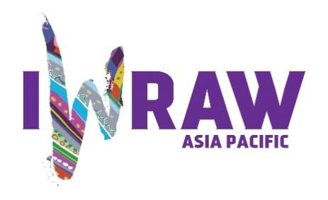
Questions for candidates to the UN Committee on Elimination for All Forms of Discrimination Against Women (CEDAW Committee)
Please provide responses that are as precise as possible and in no more than 200 words per question.

- Why do you want to be a member of the Committee on the Elimination of All Forms of Discrimination against Women?
Jurist, and building on the strength of my ministerial and diplomatic experience, I wish at a time when global challenges are crucial, to
- Ensure a new vision of equality as a key factor of reconstruction in the current Covid Crisis
- Achieve the Strengthening Reform of TB process in order to reinforce Women’s rights and the Multilateral system
- Accelerate the implementation of the CEDAW Convention to successfully change the Status of Women from victims to leaders , in line with SDGs
- Achieve the objective : Parity by 2030
- Succeed in the mobilisation of the International community in favor of Youth , through Generation Equality Forum

- What are your specific areas of expertise in relation to CEDAW? Please provide examples as appropriate.
I specialise in
- Constitutional and Institutional architecture
- Leadership in politics and economic empowerment
- Women in conflicts and post conflicts

3. What do you think are the most critical and emerging issues for women’s human rights and gender equality? Please provide 1-2 examples.
Everywhere women remain the first victims of violence, crisis and conflicts, they are in the meantime the leading forces of sustainable change and peace. The CEDAW Convention is the response to build back better.
The COVID Crisis has severely impacted Women’s rights. We have to put gender equality at the heart of reconstruction.
Facing new challenges, such as migrations, climate change, poverty, organic food, gender equality has to be a strategic factor of change
I have supported the first Inclusive Global Charter on Artificial Intelligence, to avoid the formation of new structural inequalities in the design and implementation of the new world

4. How will you ensure that the rights and issues of the most marginalised groups of women are addressed by the Committee? What measures should States take to ensure the political participation of marginalized groups of women in political life, at the local, national and international levels, including enhancing representation within the CEDAW Committee?
Inclusiveness and equality have to be considered as leading forces of sustainable change. I promote a change of paradigm on the basis of the SDG’s principle ´no one left behind´ and through the full implementation of the CEDAW Convention which is an operational roadmap as well one of the only internationally binding instrument on women’s rights.
To reach this goal, the Committee pays the utmost attention to the most vulnerable women and systematically addresses appropriate questions to States in the context of its dialogues. This is also the aim of the CEDAW General Recommendations (GR) such as the GR on Women in Conflicts, GR on Rural Women, or the current GR on Women victim of Trafficking in the context of Migrations.
In the framework of its Communications and Enquiries under the Optional Protocol, the Committee pays particular attention to marginalised groups of women.
Girls’-education, combatting against all forms of discriminations, condemning hate speech and stereotypes, and promoting special temporary measures such as quota are priorities in this matter.
In the economic field, the implementation of indicators on equality and diversity, within companies, constitutes a key factor of inclusiveness.

5. What do you think are the areas where the Committee can further strengthen international women’s rights standards?
I propose to respond to the COVID crisis by putting equality in the national and international strategies, through the consolidation of the national legal frameworks and progress on effective equality.
We need to speed up the application of the CEDAW Convention in order to address the current challenges: climate change, sustainable development, migrations, artificial intelligence, organic food, trafficking.
We have to create innovative ways of working, such as knowledge hubs, webinars, regional meetings

6. What has been your experience of working with the women’s rights movement in your country or globally?
As Minister for Women’s rights, I have maintained the best links with national, European and international civil society and women’s rights organizations. Through regular meetings and constant listening, I maintain a fruitful and useful dialogue. I am convinced that progress has to be achieved by working closely with women’s organizations, in particular feminist grassroots movements.
I am particularly sensitive to the situation of Women Human Rights defenders

7. State parties to CEDAW are required to take steps to implement the Convention. How do you propose to help guide States in the effective implementation of Convention standards? How will you guide States in the removal of reservations to the Convention, especially reservations that relate to the object and purpose of the Convention (Articles 2 and 16)?
The paradigm must change and gender equality has to be considered as a force for action and positive social transformation.
It means a new systemic approach based on:
- the establishment of a process for updating the implementation of the Convention;
- the reinforcement of the national machinery to put gender equality at the center of national strategies and adopt gender-responsive public policies;
- the definition of clear objectives on key issues (laws against violences, parity by 2030 , economic empowerment, equality before the law …);
- Gender equality must be mainstreamed as a priority in the Official development assistance, in order to reinforce national capacities and strengthen civil society and women’s organizations.

8. What can the Committee do to further strengthen its engagement with other stakeholders and accountability mechanisms at country level, including gender machinery, national human rights institutions (NHRIs), members of parliament, judicial actors, civil society organizations and UN agencies?
The CEDAW Committee has already built a powerful architecture with different entities, such as IPU, NIHRI, ILO, UN Women, the Generation Equality Forum. Personally involved in all these areas, I think that we need to go further
- By creating a CEDAW Hub Knowledge (currently under study)
- By creating regional meetings in line with Regional Organisations
- By strengthening our dialogue with Civil Society and women’s organisations and Human Rights Defenders
- By developing Focal Points in direct contact with the different UN entities, as I am currently with IPU and UN Women

9. How do you see the CEDAW Committee strengthening the domestic and international environment for holding business/private actors responsible for violations under the Convention?
The CEDAW Committee considers that the obligations of the States Parties apply at all levels, in all fields, including in the form of extra territorial obligations. The private sector is a part of the State responsibility under the CEDAW Convention in case of violation of fundamental rights
In a positive way the private sector is a powerful actor in order to ensure gender equality at work. The CEDAW Committee highlights the best practices based on indicators, outcome objectives in order to ensure protection, fulfilment and promotion of all women’s human rights .
The Committee supports international coalitions in this matter.

10. How do you see the CEDAW Committee and the review process contributing to the delivery of global commitments on gender equality, including under the 2030 Agenda for Sustainable Development?
The role and the place of the CEDAW Committee in the Global Commitment and Review 2020 is critical. Gender equality is the marker, the DNA of a sustainable world. As CEDAW focal point on the Review 2020 and as Chair of the CEDAW Working Group on SDGs, I am on the front lines of this global challenge.
With the current informal Inter- Committees Group on COVID, we try to formalise a systemic vision on new ways of working through a stronger harmonisation and coherence in a short and medium term. The CEDAW Committee has to be a leading force in the Review process considering the current challenges we face on equality.
It is the key point of my engagement

