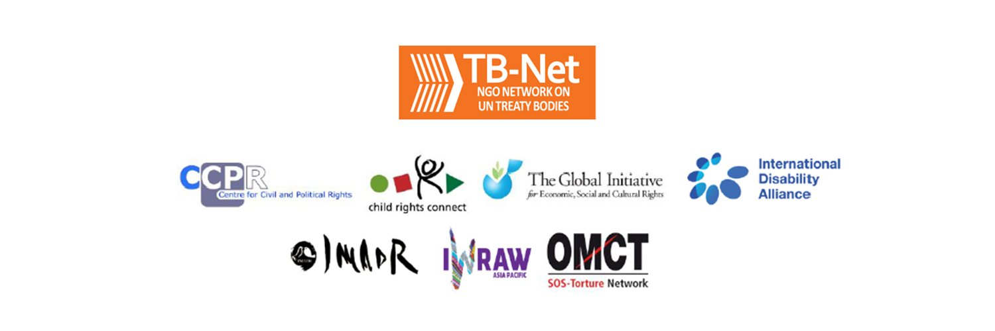

Elections 2020

Committee on the Rights of Persons with Disabilities (CRPD)

Committee on the Elimination of Discrimination Against Women (CEDAW)

Human Rights Committee (HRCttee)

Committee on the Rights of the Child (CRC)

  - Questionnaire for candidates
Four UN Treaty Bodies (Committee on the Rights of Persons with Disabilities (CRPD), Committee on the Elimination of Discrimination Against Women (CEDAW), Human Rights Committee (HRCttee) and Committee on the Rights of the Child (CRC)) will have elections organised in June 2020.
In order to strengthen the treaty bodies, the International Disability Alliance, Child Rights Connect and IWRAW Asia-Pacific– as part of TB-Net, the NGO network on the UN Treaty Bodies – seek to promote quality, independence and diversity of treaty body membership through transparent and participators nomination and elections processes.
This questionnaire, which is sent to all nominated candidates and is based on the criteria set forth in the relevant treaties and in the GA Resolution 68/268, will enable all States and other stakeholders to better understand the skills, experiences and motivation of running candidates to CRPD, CEDAW, and CRC in advance of the elections.
The written responses to the questionnaires will be made available on the website www.untbelections.org.
This initiative does not imply that we support or oppose any individual candidates.

Questions for all treaty bodies candidates

- Name: Natasha STOTT DESPOJA

- Nationality: Australian

- Current position: Chair, Our Watch (the national organisation to Prevent Violence Against Women and their Children).
4. Are you currently holding or have you previously held any position on behalf of, or for, your Government (Executive branch) that may compromise your actual or perceived independence and impartiality? If so, please give details:
In selecting a candidate for CEDAW, the Australian Government undertook an independent and accountable process. Candidates were invited to submit expressions of interest and provide CV information. I was selected after a rigorous process and am completely independent of Government, although I am honoured to be the Australian nominee.
I am a former Member of the Australian Federal Parliament (1995-2008) yet, I am from a different political party from the Minister who selected me. I think this attests to Australia’s commitment to impartial and independent candidates. I have never held executive power.
I can assure you of my independence and my impartiality and know that others in civil society, and even within the Australian Parliament and Executive, would vouch for that.
5. Please indicate any current or potential conflict of interest that may prevent you from exercising independence and impartiality in your work as a member of a UN treaty body:
I have no conflicts – real or perceived – in relation to exercising independence and impartiality as a member of a UN treaty body. I understand and take seriously the role of CEDAW in holding Member States to account, including my own. I am not a Member of anu Parliament or employed by the government.
6. Was the nomination process for your candidacy a transparent and participatory process? Was civil society or other relevant stakeholders involved?
The process was conducted by Government, but it was a transparent and accountable one. It was a comprehensive process in which anyone with the requisite experience and expertise was invited to apply. The Minister chose from a shortlist and based her decision on the circulated independent criteria. The criteria was supported by civil society and other political parties, as I understand it.
Much of the initiative for Australia to nominate a candidate for CEDAW – after nearly thirty years – came from civil society.
I am pleased to have the wide-ranging support of civil society and Australian Human Rights Commission (Australia’s Independent NHRI).
7. During your possible service as a Committee member, what other positions or professional activities do you intend to engage in?
I will continue to work –in a not for profit capacity – for gender equality in Australia, with specific attention to my work as Chair of Our Watch. I will continue not-for-profit board and patron work that advances human rights in my home country, the region and more broadly. These commitments are flexible. I do not hold a full time academic or government role.
8. The commitments as a Committee member are very time-consuming during and outside session time. Will you have the capacity to dedicate the necessary time to the work of the Committee?
Absolutely. I will work hard on the Committee and will dedicate my time to whatever is requested of me. I do not hold any other full time academic or government role. I am passionate about this role and pledge to be a committed and hard-working member. I would be honoured to serve.
9. What are the current and main challenges that you see for the treaty body system and what are your ideas for improvement?
I support the strengthening and enhancing the effective functioning of the human rights treaty body system. Collaboration within and across the committee system remains an important issue and something I am keen to be a part of strengthening and promoting. The issue of overdue or non-reporting is a significant impediment to CEDAW. Educating some governments, as well as being mindful that there are resource needs and other issues that affect smaller or developing nations is something of which I am acutely conscious. It is essential that the treaties body system is independent, and I commit to being an independent member and advocate. Resourcing remains a challenge and I am open to recommendations and suggestions as to how to work creatively to address resourcing needs, as well as Covid-imposed restrictions. We need to take into account the needs of small poor remote states, and consider potential other meeting places inorder to reduce some of the onus on our region. Ensuring an intersectuional approach and the genuine enagement and involvement of civil society is a priority for me.
Link to your full resume:
Arabic | English | French | Russian | Spanish
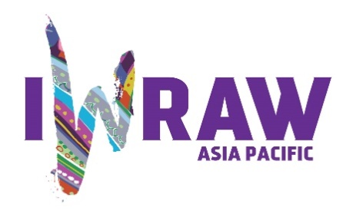
Questions for candidates to the UN Committee on Elimination for All Forms of Discrimination Against Women (CEDAW Committee)
Please provide responses that are as precise as possible and in no more than 200 words per question.
- Why do you want to be a member of the Committee on the Elimination of All Forms of Discrimination against Women?
As a lifelong advocate for women’s rights, I recognise CEDAW as a powerful human rights tool for the advancing and protecting women’s rights. I have long understood the work of CEDAW and have referred to the Convention and the Committee’s work throughout my working life and in different roles. I was an advocate for Australia to ratify the Optional Protocol when I was as a Senator. I want to contribute to the protection and advancement of women’s rights around the globe, drawing on my personal and professional experience. I would be honoured to work on many issues affecting women, but specifically to eliminate violence against women and girls as well as ensure greater representation of women in decision-making institutions. I believe in an intersectional approach and I am particularly committed to seeing Australia and the Pacific region reflected and represented. It is almost thirty years since Australia had a member on CEDAW.
2. What are your specific areas of expertise in relation to CEDAW? Please provide examples as appropriate.
I believe I bring wide-ranging expertise in policy and legislation that affects women and communities. I tabled Australia’s first-ever national paid parental leave legislation in the Australian Federal Parliament (in 2002) and have spear-headed legislation and amendments that assisted women’s reproductive rights; sought to protect women from false and misleading pregnancy counselling advertising; and furthered flexible work and family practices. I initiated changes to the parliamentary standing orders so that women could breastfeed in the Australian parliament and I lead campaigns to remove the Goods and Services Tax from sanitary items.
Always, I have kept the issues of women and girls at the forefront of my work, regardless of my portfolios, I have always applied a gender lens to policy.
My work now centres on primary prevention of violence against women the link between gender inequality and violence against women. I have published a book on this issue (March 2019). Our Watch (the organisation which I chair), has been responsible for world-leading work on primary prevention of violence against women and I would bring this work and expertise to CEDAW.
I have also had international, specifically regional, experience through my work as Ambassador. I am acutely aware of many of the challenges facing women in my region.
3. What do you think are the most critical and emerging issues for women’s human rights and gender equality? Please provide 1-2 examples.
The impact of COVID_19 on women cannot be underestimated. Based on international evidence about disasters, the rates of violence against women has and will increase. This includes many forms of violence including domestic and family violence, sexual harassment, online and image-based abuse, reproductive coercion, institutional violence and neglect, racist abuse and workplace abuse.
Regardless of the current circumstance, the issue of gendered violence (in its myriad forms) remains one of the worst manifestations of gender inequality and must be addressed though challenging the attitudes and behaviours that give rise to this violence.
This pandemic has also highlighted and exacerbated inequalities in the workforce, with many women working on the frontline and providing services to the community. The kinds of care work that are overwhelmingly performed by women are generally devalued and less well paid but have been crucial to the crisis response. The issue of women’s economic empowerment will be crucial to future CEDAW work, this includes how we value and support women in unpaid and under-valued roles.
There are many critical issues affecting women, but the Covid pandemic requires us to shine a gender lens on policy as never before.
4. How will you ensure that the rights and issues of the most marginalised groups of women are addressed by the Committee? What measures should States take to ensure the political participation of marginalized groups of women in political life, at the local, national and international levels, including enhancing representation within the CEDAW Committee?
Any approach – by CEDAW, Governments or civil society, NGOs and other groups -- must be an intersectional one. It also requires support for and critical engagement with civil society.
I am passionate about the diversity and difference of women being reflected and represented in all decision-making institutions, including in parliaments and at every level. This requires a multi-layered strategy including, among other things, education, support, resources, quotas and political will.
In the region, I have supported political quotas, but I have also worked to provide support and resources and networks for women aspiring to and entering legislatures. I have hosted events, such as the Pacific Women’s Parliamentary Partnership Forum, to bring together women from across different jurisdictions, countries and parties to discuss policies and practices that better support and assist women and create fairer societies.
I have spent my entire adult life encouraging greater representation of women in the parliament (I entered the Australian federal parliament as the youngest woman ever to do so) and will continue to work for women around the world to be represented in increased numbers but also with the necessary support structures, especially women from traditionally under-represented or unrepresented backgrounds.
5. What do you think are the areas where the Committee can further strengthen international women’s rights standards?
The challenge of the post-Covid era will be ensuring we do not lose decades of progress in the area of women’s rights in countries across the globe. I believe there are a range of areas require strengthening. Women’s role in peacekeeping and sustaining peace as well as women’s rights in the climate change crisis. Access to land, employment, income as well as protection from harm and violence are emerging issues for countries affected by climate change. This has a disproportionate effect on women and girls. This is an area of work that can be strengthened and prioritised. Greater support for NGOs in providing reports to CEDAW is another way of strengthening the information available to CEDAW members. Input from civil society and NGOs will and should help shape this agenda
6. What has been your experience of working with the women’s rights movement in your country or globally?
I grew up in the women’s movement, raised by a feminist mother in a single parent household. I embraced sisterhood from an early age and understand the importance of activism as well as the importance of having women in positions of political power.
I now work in the not-for-profit sector to prevent gendered violence.
I have served as a diplomat, as Australia’s Ambassador for Women and Girls, so I have worked in the region and internationally on gender equality, specifically supporting women’s economic empowerment, promoting women’s agency and leadership and on eliminating violence against women and girls.
I have attended multiple CSWs, addressed the UN Security Council on the issues affecting displaced women and children and visited many nations as part of Australia’s commitment to gender equality in international development work. I have represented Australia and other groups at multi-lateral and regional fora.
I work closely with civil society.
I am involved with groups such as Plan, ActionAid, the YWCA, UN Women Australia, I am a member of the GWU Global Women’s Institute Advisory Board, have served on the World Bank Gender Advisory Board and also on a UN High Level Working Group on Women’s health and human rights.
7. State parties to CEDAW are required to take steps to implement the Convention. How do you propose to help guide States in the effective implementation of Convention standards? How will you guide States in the removal of reservations to the Convention, especially reservations that relate to the object and purpose of the Convention (Articles 2 and 16)?
Experts explaining the importance of the Convention is a good start. Member States also need to be encouraged to allocate appropriate resources from the UN budget to ensure treaty bodies can carry out their mandate.
The issue of the reservations, is a significant obstacle for the Convention, especially to the key articles 2 and 16, as you identify. The Committee will continue to need to push for withdrawal of any reservations, this can be done with the persuasion of independent experts but also working with those in-country to convince governments that those reservations are incompatible with the purpose and objects of the Convention.
Again, work with civil society is fundamental, just as working through Governments and Parliaments, NGOs. The issue of direct reporting by NGOs is a part of this discussion.

8. What can the Committee do to further strengthen its engagement with other stakeholders and accountability mechanisms at country level, including gender machinery, national human rights institutions (NHRIs), members of parliament, judicial actors, civil society organizations and UN agencies?
While there are processes that can facilitate this strengthening of engagement, there are also things individuals can do. I pledge to work collaboratively within CEDAW and across the UN system, including with UN Women and across other treaty bodies to ensure better engagement. NHIs are critical to the work of the Committee and ensuring regular contact, meetings and collaboration is critical. I am used to working with a range of groups, across sectors and would like to see greater engagement across the UN system. It is one of the reasons I am running for this position. Ongoing recognition of the importance of civil society – and ensuring civil society has access – is relevant. This requires resources as well as will.
Exploring non traditional forms of communication especially during this covid era will be essential. Getting people together through meetings, including virtual meetings, will be a new feature. Advertising the work of CEDAW is essential too.
9. How do you see the CEDAW Committee strengthening the domestic and international environment for holding business/private actors responsible for violations under the Convention?
The role of the private sector in playing a transformative role post Covid will be a critical one. Similarly, those actors responsible for violations, including violence against women, land grabs and other violations should be held to account. The intersection between violations under the Convention and the emerging issue of the impact of climate change on women will put some private actors and businesses increasingly in the frame. Again, providing opportunities for greater engagement of civil society and arguably direct reporting opportunities for NGOs can provide outlets for addressing such issues. I recognise treaty obligations apply to countries, but arguably corporate engagement is key to successful UN work.
I am committed to discussing ways we can strengthen domestic and international environments for this purpose. It reflects my work in the Australian Parliament where I worked to create extra territorial legislation to ensure companies were held to account for transgressions in human rights and environmental protection. It is a challenging area of law, domestically and globally.
10. How do you see the CEDAW Committee and the review process contributing to the delivery of global commitments on gender equality, including under the 2030 Agenda for Sustainable Development?
CEDAW is vital to holding Member States and the UN to account on the protection and advancement of women’s rights but it can also guide Member States on how to advance these rights. Achieving the SDGs is, of course, contingent upon achieving gender equality. There is an added impetus for the UN and associated bodies and Member States to work harder on women’s rights at this time. Mainstreaming women’s rights into the broader human rights agenda, and within other treaty bodies, is essential. The review process can help ensure the human rights treaty body system is strengthened and enhanced. This requires additional resources, independence of the bodies and expert representation on the committee. CEDAW’s role cannot be underestimated in this process.

