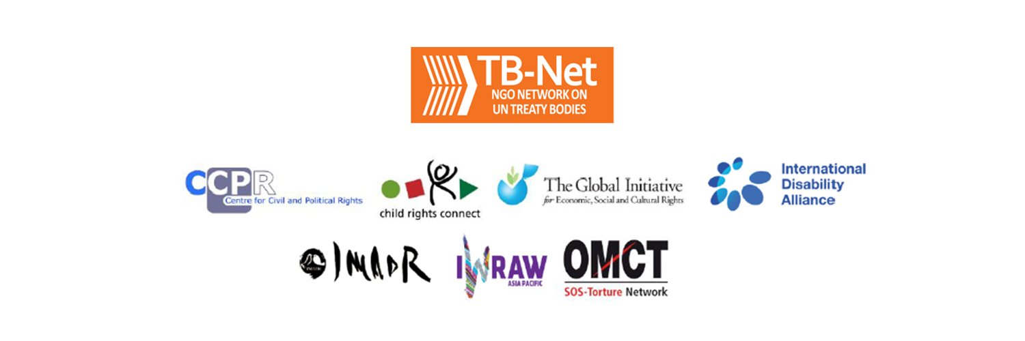

Elections 2020

Committee on the Rights of Persons with Disabilities (CRPD)

Committee on the Elimination of Discrimination Against Women (CEDAW)

Human Rights Committee (HRCttee)

Committee on the Rights of the Child (CRC)

  - Questionnaire for candidates
Four UN Treaty Bodies (Committee on the Rights of Persons with Disabilities (CRPD), Committee on the Elimination of Discrimination Against Women (CEDAW), Human Rights Committee (HRCttee) and Committee on the Rights of the Child (CRC)) will have elections organised in June 2020.
In order to strengthen the treaty bodies, the International Disability Alliance, Child Rights Connect and IWRAW Asia-Pacific– as part of TB-Net, the NGO network on the UN Treaty Bodies – seek to promote quality, independence and diversity of treaty body membership through transparent and participators nomination and elections processes.
This questionnaire, which is sent to all nominated candidates and is based on the criteria set forth in the relevant treaties and in the GA Resolution 68/268, will enable all States and other stakeholders to better understand the skills, experiences and motivation of running candidates to CRPD, CEDAW, and CRC in advance of the elections.
The written responses to the questionnaires will be made available on the website www.untbelections.org.
This initiative does not imply that we support or oppose any individual candidates.

Questions for all treaty bodies candidates

1. Name: Marion Bethel

2. Nationality: The Bahamas

3. Current position: UN CEDAW Committee Member

4. Are you currently holding or have you previously held any position on behalf of, or for, your Government (Executive branch) that may compromise your actual or perceived independence and impartiality? If so, please give details:
No.

5. Please indicate any current or potential conflict of interest that may prevent you from exercising independence and impartiality in your work as a member of a UN treaty body:
N.A.

6. Was the nomination process for your candidacy a transparent and participatory process? Was civil society or other relevant stakeholders involved?
As a candidate for re-election, there was no nomination process that involved civil society or other stakeholders.

7. During your possible service as a Committee member, what other positions or professional activities do you intend to engage in?
I will be continuing my professional work as an attorney in the law firm of Sears & Co in Nassau, Bahamas.

8. The commitments as a Committee member are very time-consuming during and outside session time. Will you have the capacity to dedicate the necessary time to the work of the Committee?
Yes! I have served on the Committee for the past three and a half years.

9. What are the current and main challenges that you see for the treaty body system and what are your ideas for improvement?
The substantial reporting requirements under the TB system, the UPR Review and Special Procedures have been a major challenge for States Parties. In my experience on the Committee it appears that that the Simplified Reporting Procedure has facilitated this matter. Instead of submitting periodic reports, States parties can opt to receive questions from the treaty bodies (which are based on the Concluding Observations from the previous review as well as new developments). In this way, the reporting process is reduced from two steps (State party report and replies to the list of issues) to one step.
Further, the coherence of TBs in regard to rules of procedure and working methods concerning, inter alia, constructive dialogues, inquiries, general recommendations, remains a challenge. For example, the Inquiry standard operating procedures for TBS are different. It would facilitate the working of the entire system to have a harmonised process in order to provide SPs with a predictable and transparent format. There is also the issue of SPs having to respond to several Inquiries and/or State visits from different TBs and Special procedures holders at the same time. It is worthwhile exploring whether and how two or more Inquiries or Special Procedures’ visits may take place at the same time in one SP, especially where there may be overlap in subject matter.

Link to your full resume:

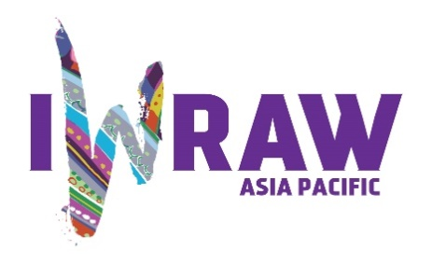
Questions for candidates to the UN Committee on Elimination for All Forms of Discrimination Against Women (CEDAW Committee)
Please provide responses that are as precise as possible and in no more than 200 words per question.

- Why do you want to be a member of the Committee on the Elimination of All Forms of Discrimination against Women?
The past three and a half years on the Committee have provided a strong foundation on which to build the advancement of women’s human rights as a member of the Committee. On re-election to the Committee for a second term, I will endeavour to advance the work commenced in this last term concerning the economic and social rights of women. Macro-economic policies can enable or limit the possibilities for women in regard to, inter alia, the quantity and quality of employment opportunities, the burden of unpaid care and domestic work, the distribution of resources towards women and the availability of resources to governments to finance social policies and protection programmes to advance women’s human rights. My focus here addresses the socio-economic empowerment of marginalised women with particular attention to rural women, domestic workers, women on plantations, migrant women, factory workers, home-based women and minority women.

Under Article 13 of the Convention, I have consistently interrogated the issues of macro-economic policies in regard to public revenue, taxation, unpaid care, social protection for women and the economic empowerment of women.

- What are your specific areas of expertise in relation to CEDAW? Please provide examples as appropriate.

My legal training is in the English common law system. During the constructive dialogues, this expertise enables a proficient understanding of and response to constitutional and other legal issues inclusive of gender-based violence, nationality and statelessness legislation and family law in Commonwealth countries. In 2019 I executed a comprehensive review of the issue of marital rape and drafted a document on the reform of marital rape legislation in The Commonwealth.

I have worked closely over the years with The Bahamas’ Department of Gender & Family Affairs. Through this engagement I understand the challenges that small island developing states experience in regard to the capacity of these national machineries in the advancement of women’s human rights. Some of these challenges relate to the lack of enough human, financial and technical resources. Other challenges concern a full understanding of the concept of substantive equality berween women and men and the political will and capacity to deliver based on that understanding. Further, I have participated in the review of The Bahamas’ draft National Policy on Gender Affairs and appreciate the absolute need for conceptual clarity in regard to substantive equality and the mapping of gender inequalities that require sustained and programmatic attention in this regard.

3. What do you think are the most critical and emerging issues for women’s human rights and gender equality? Please provide 1-2 examples.
One of the critical issues for women’s human rights is the on-going economic empowerment of women and the related social protections. The digital platform economy and artificial intelligence driven analytics that now power the global economy pose both opportunites and challenges for women’s human rights. Given the existing inequalities in access to data and analytic capacities, we need a gender responsive human rights approach to both digital platforms and AI based on global standards and a broad-based normative consensus. Enhanced education and training in these areas for women working in all sectors of the economy are critical and urgent.

- How will you ensure that the rights and issues of the most marginalised groups of women are addressed by the Committee? What measures should States take to ensure the political participation of marginalized groups of women in political life, at the local, national and international levels, including enhancing representation within the CEDAW Committee?

During the constructive dialogues with States Parties, it is crucial to amplify the voices and experiences of marginalised groups of women from vulnerable communities and further, insist that they be active participants in the national policy-making processes, monitoring and evaluation of the same and the correlated action plans.

States Parties through the national action plans and programmes of their national machineries must commit to establishing on-going education, training, mentoring of and election of marginalised women for political office and nomination to the CEDAW Committee.

Further, SPs must recognise and state categorically in their national policies the value of the expertise and lived experiences of marginalised women.

5. What do you think are the areas where the Committee can further strengthen international women’s rights standards?
A key component of the process of strengthening international women’s rights standards is the harmonisation of the interpretation of standards, active communication and collaboration between the various treaty bodies on both substantive and procedural issues. There is also room to increase collaboration between CEDAW and other UN bodies such as the HRC, Special Procedures and the UPR. It is critical, for esample, that the interpretation of substantive equality under the CEDAW Convention be used systematically by other treaty bodies and UN bodies.
Further, there are other UN bodies such as the UNDP, UNFPA and the ILO with which the CEDAW Committee can collaborate in order to strengthen women’s rights standards.

6. What has been your experience of working with the women’s rights movement in your country or globally?
I have been an active participant in the women’s rights movement in The Bahamas and the Caribbean since the mid-1980s. During this period we worked diligently in the areas of sexual and reproductive health rights and gender-based violence against women. In 1992 this activism resulted in legislative reform in regard to the Sexual Offences.
In the 1990s I attended the successive World Conferences on human rights as follows: UN Conference on Human Rights in Vienna in 1991 as a Delegate of the Caribbean Association for Feminist Research and Action; the International Conference on Population and Development in Cairo in 1994; and the UN Fifth World Conference on Women in Beijing in 1995. This exposure and experience facilitated increased capacity and contribution to the women’s rights movement.
During the Constitutional debates of 2016 in The Bahamas to amend the Constitution to prohibit discrimination against women on the basis of sex, it was patently clear that the country could not move ahead with protecting the rights of women solely on that basis. This particular prohibition was very narrow and excluded protection of the rights of marginalised women, in particular the LBTQ community. Women’s rights activists could not ignore the rights of women concerning discrimination based on gender and sexual orientation. This referendum was defeated for several reasons, in my view, inclusive of the fact that the political vision was limited to a narrow interpretation of “non-discrimination on the basis of sex”.

7. State parties to CEDAW are required to take steps to implement the Convention. How do you propose to help guide States in the effective implementation of Convention standards? How will you guide States in the removal of reservations to the Convention, especially reservations that relate to the object and purpose of the Convention (Articles 2 and 16)?
There are opporutinites both pre- and post-the Constructive Dialogue to facilitate States with the effective implemetation of the Convention. Committee members are now engaged in the process of mock sessions prior to the constructive dialogues. Further, members are also engaged with SPs after the Concluding Observations to assist with implementation of recommendations. The continuity of engagement by the Committee with the SPs can facilitate effective implementation of the Convention.
In regard to the removal of reservations, we can draw on the advances made by other SPs in specific regions and discuss with the SPs the viability of adopting a similar effective policy, approach or practice. Further, the SP must appreciate that reservations in regard to Articles 2 and 16 severely undermine the spirit of the Convention.

8. What can the Committee do to further strengthen its engagement with other stakeholders and accountability mechanisms at country level, including gender machinery, national human rights institutions (NHRIs), members of parliament, judicial actors, civil society organizations and UN agencies?
It is possible for Committee members to host systematic regional meetings with the various stakeholders in order to discuss the Convention and stakeholders’ concerns, challenges and opportunities in advancing women’s humans rights and imnplemetaton of the Convention. During these meetings which can be virtual, stakeholders are enabled to share ideas and effective practices with the Committee in order to inform our own procedures and deliberations.

9. How do you see the CEDAW Committee strengthening the domestic and international environment for holding business/private actors responsible for violations under the Convention?
During the constructive dialogues Committee members can make ample use of the “UN Guiding Principles On Business and Human Rights” of 2011 which are endorsed by the Human Rights Council. States Parties must be accountable for policies, legislation, regulation and adjudication of businesses in their jurisdictions. In this regard SPs should ensure that all businesses in their territories respect women’s human rights throughout the course of their operations.
Further, it is important for the Committee to advocate for a UN Convention that addresses the responsibility of business/private actors and the protection of human rights.

10. How do you see the CEDAW Committee and the review process contributing to the delivery of global commitments on gender equality, including under the 2030 Agenda for Sustainable Development?
The Committee has a standing Workging Group on the 2030 Sustainable Goals. The Working Group continues to do an excellent job of promoting CEDAW principles within the SDG framework. Collaboration with women’s NGOs and CSOs is critical to ensuring the alignment of commitments under the Convention with those of the SDGs.

