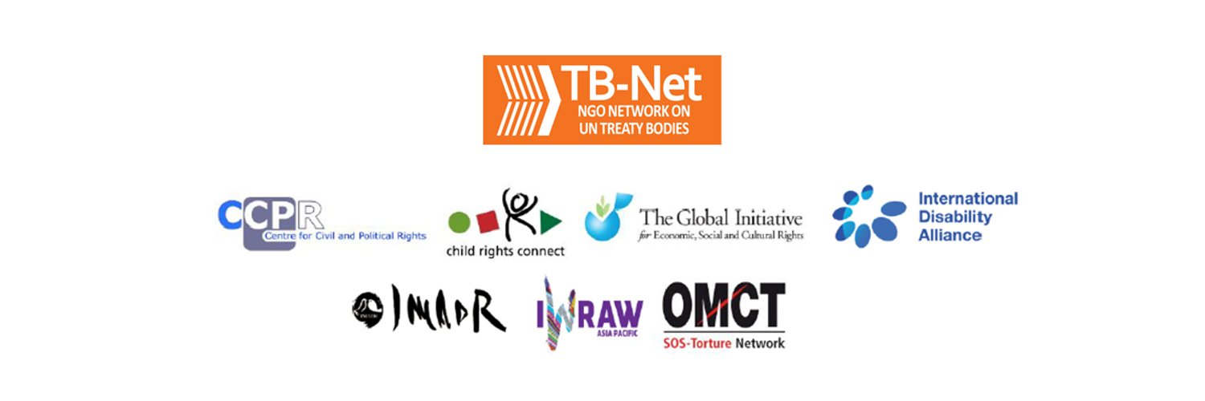

Elections 2020

Committee on the Rights of Persons with Disabilities (CRPD)

Committee on the Elimination of Discrimination Against Women (CEDAW)

Human Rights Committee (HRCttee)

Committee on the Rights of the Child (CRC)

  - Questionnaire for candidates
Four UN Treaty Bodies (Committee on the Rights of Persons with Disabilities (CRPD), Committee on the Elimination of Discrimination Against Women (CEDAW), Human Rights Committee (HRCttee) and Committee on the Rights of the Child (CRC)) will have elections organised in June 2020.
In order to strengthen the treaty bodies, the International Disability Alliance, Child Rights Connect and IWRAW Asia-Pacific– as part of TB-Net, the NGO network on the UN Treaty Bodies – seek to promote quality, independence and diversity of treaty body membership through transparent and participators nomination and elections processes.
This questionnaire, which is sent to all nominated candidates and is based on the criteria set forth in the relevant treaties and in the GA Resolution 68/268, will enable all States and other stakeholders to better understand the skills, experiences and motivation of running candidates to CRPD, CEDAW, and CRC in advance of the elections.
The written responses to the questionnaires will be made available on the website www.untbelections.org.
This initiative does not imply that we support or oppose any individual candidates.

Questions for all treaty bodies candidates

1. Name: HILARY GBEDEMAH

2. Nationality: GHANAIAN

3. Current position: CHAIR, CEDAW COMMITTEE,
CHAIR OF THE CHAIRS OF THE TREATY BODIES
4. Are you currently holding or have you previously held any position on behalf of, or for, your Government (Executive branch) that may compromise your actual or perceived independence and impartiality? If so, please give details:
NO
5. Please indicate any current or potential conflict of interest that may prevent you from exercising independence and impartiality in your work as a member of a UN treaty body:
NO
6. Was the nomination process for your candidacy a transparent and participatory process? Was civil society or other relevant stakeholders involved?
YES
7. During your possible service as a Committee member, what other positions or professional activities do you intend to engage in?
N/A
8. The commitments as a Committee member are very time-consuming during and outside session time. Will you have the capacity to dedicate the necessary time to the work of the Committee?
YES
9. What are the current and main challenges that you see for the treaty body system and what are your ideas for improvement?
Currently there are resource challenges, but the alignments envisaged through the treaty Body Strengthening System, and the 2020 review process will be instrumental in providing an indication of the remaining gaps and opportunities.
Link to your full resume:

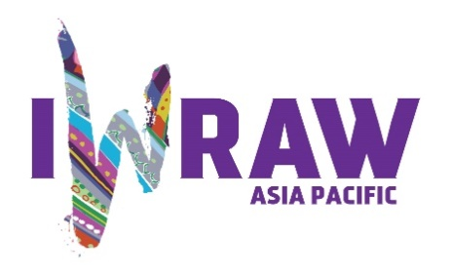
Questions for candidates to the UN Committee on Elimination for All Forms of Discrimination Against Women (CEDAW Committee)
Please provide responses that are as precise as possible and in no more than 200 words per question.

1. Why do you want to be a member of the Committee on the Elimination of All Forms of Discrimination against Women?
To advance the rights of women globally through the Convention, harnessing my experience on the Committee, expertise and institutional learning.
2. What are your specific areas of expertise in relation to CEDAW? Please provide examples as appropriate.
Violence against Women, Health, Education, Family Law, Access to Justice, Climate Change, Women’s representation, Employment and Economic Rights
3. What do you think are the most critical and emerging issues for women’s human rights and gender equality? Please provide 1-2 examples.
The understanding and implementation of substantive equality; ensuring that the gains hitherto made in the advancement of women’s rights are not lost in the current global situation.
4. How will you ensure that the rights and issues of the most marginalised groups of women are addressed by the Committee? What measures should States take to ensure the political participation of marginalized groups of women in political life, at the local, national and international levels, including enhancing representation within the CEDAW Committee?
These issues which are well articulated in the Committee’s jurisprudence as contained in the General Recommendations, Inquiry Reports and Communications will continue to be brought up during the constructive dialogue, ensuring their inclusion in the concluding observations, and the Committee’s implementation procedures. Temporary special measures will also be advocated, and states’ parties’ attention will be drawn to the availability of technical assistance to achieve these goals which will advance both the human rights and developmental objectives of the Convention.
5. What do you think are the areas where the Committee can further strengthen international women’s rights standards?
a. Women’s education and economic empowerment especially in the COVID era, harnessing the use of technology.
b. Collaboration across treaty bodies and UN entities in various ways, greater visibility, cross learning and sharing of experiences and more robust engagement with instruments such as the SDGs.
6. What has been your experience of working with the women’s rights movement in your country or globally?
In country, I have been involved in training, advocacy, policy and research. Knowledge of women’s rights and implementation has increased but enacting accompanying legislation has taken longer. Internationally, I have been engaged in capacity building for members of the judiciary, parliamentarians, various officials across the board, and civil society on all the thematic areas of the Convention and the accompanying General Recommendations. This has resulted in legislation being enacted, reports produced in a timelier manner, and a greater appreciation that when the Convention becomes a benchmark for women’s rights, it can be used as a lever for change (especially the education, health, public office, social and economic articles) and societal development.
7. State parties to CEDAW are required to take steps to implement the Convention. How do you propose to help guide States in the effective implementation of Convention standards? How will you guide States in the removal of reservations to the Convention, especially reservations that relate to the object and purpose of the Convention (Articles 2 and 16)?
This is a progressive procedure that requires engagement with critical stakeholders within the states and to allay the rationale behind the reservations in the first place. It is also important for states to conceptualise how the optimum social, economic and developmental benefit is gained from the Convention as a whole. States are called upon at landmark events to lift the reservations and they also see examples of others that have done so without a loss of core values sometimes through peer engagement. Already, this is being done with considerable success.
8. What can the Committee do to further strengthen its engagement with other stakeholders and accountability mechanisms at country level, including gender machinery, national human rights institutions (NHRIs), members of parliament, judicial actors, civil society organizations and UN agencies?
By keeping the avenues for engagement and exchange of information open, and ensuring the respective roles of parliament and other state party actors in the report preparation, dialogue, dissemination and implementation of concluding observations. The Committee should articulate and require minimum standards for the National Women’s Machineries and NHRIs’ compliance with the Paris Principles. During my tenure as Chair, NHRIs now have the opportunity of making a statement at the commencement of the dialogue.
The Committee continues to issue joint statements with other bodies.
9. How do you see the CEDAW Committee strengthening the domestic and international environment for holding business/private actors responsible for violations under the Convention?
The Committee continues to engage states parties in the constructive dialogues within the framework of the UN Guiding Principles on Human Rights and Business which applies to all states, business enterprises, transnational irrespective of size, sector, location and structure. Having been part of a Consultation on a “Gender Lens to the UN Guiding Principles on Business and Human Rights” in 2019, this assessment examined several aspects pertaining to gender sensitive compliance among business actors. These include gender equality and women's empowerment policies with SDG 5, the legal framework, procurement, gender-sensitivity and responsiveness in the areas of trade and investment policies, institutions, due diligence, corporate policy commitments and access to justice. These apply to conflict contexts as well. These will continue to be part of the dialogue and standards in which states will be engaged. CEDAW now routinely questions States parties under Article 13 on their extraterritorial responsibilities and how their financial policies affect women.
10. How do you see the CEDAW Committee and the review process contributing to the delivery of global commitments on gender equality, including under the 2030 Agenda for Sustainable Development?
The Committee will continue to implement the measures in the Chairs Common vision which were adopted while I was during my current tenure as Chair of the Chairs of the treaty bodies. These include the simplified reporting procedure, a continuous review of working methods to reduce overlap, more precise and actionable formulation of concluding observations, strengthened cooperation with other treaty bodies, regional mechanisms and stakeholders, to deliver comprehensively on the global commitments to gender equality.
The Committee has a Working Group on SDGs through which it takes concrete steps to promote the SDGs. It will continue to encourage States parties to report on measures taken to achieve the targets set by the SDGs, and it has revised its reporting guidelines to integrate the SDGs in order to ensure systematic reporting by States parties. Concluding Observations currently incorporate SDG targets aligned with the articles of the Convention.

