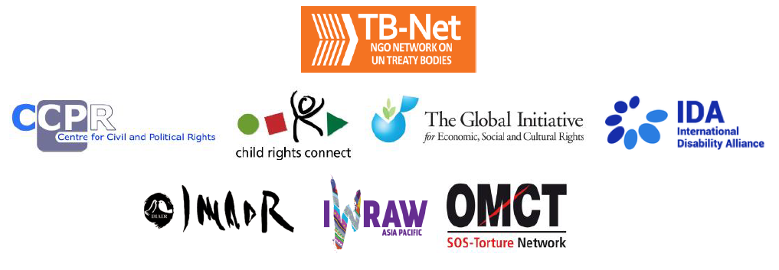

Elections 2022

Committee on the Rights of Persons with Disabilities (CRPD)

Committee on the Elimination of Discrimination Against Women (CEDAW)

Human Rights Committee (HRCttee)

Committee on the Rights of the Child (CRC)

Committee on Economic, Social and Cultural Rights (CESCR)

Subcommittee on Prevention of Torture (SPT)

Questionnaire for candidates
Six UN Treaty Bodies (Committee on the Rights of Persons with Disabilities (CRPD), Committee on the Elimination of Discrimination Against Women (CEDAW), Human Rights Committee (HRCttee), Committee on the Rights of the Child (CRC), Committee on Economic, Social and Cultural Rights (CESCR) and Subcommittee on Prevention of Torture (SPT)) will have elections organised in 2022.
In order to strengthen the treaty bodies, the International Disability Alliance, Child Rights Connect, IWRAW Asia Pacific, the Centre for Civil and Political Rights, and the Global Initiative For Economic, Social And Cultural Rights – as part of TB-Net, the NGO network on the UN Treaty Bodies – seek to promote quality, independence and diversity of treaty body membership through transparent and participatory nomination and elections processes.
This questionnaire, which is sent to all nominated candidates and is based on the criteria set forth in the relevant treaties and in the General Assembly Resolution 68/268, will enable all States and other stakeholders to better understand the skills, experiences and motivation of running candidates to CRPD, CEDAW, HRCttee, CRC and CESCR in advance of the elections.
The written responses to the questionnaires will be made available on the website www.untbelections.org, while the video responses will be shared on a dedicated YouTube page.
This initiative does not imply that we support or oppose any individual candidates.

Questions for all treaty bodies candidates

1. Name: Daphna Hacker
2. Nationality: Israeli
3. Current position: Full Professor, Head of the Women and Gender Studies Program and member of the Law Faculty, Tel Aviv University
4. Are you currently holding, or have you previously held any position on behalf of, or for, your Government (Executive branch) that may compromise your actual or perceived independence and impartiality? If so, please give details:
No
5. Please indicate any current or potential conflict of interest that may prevent you from exercising independence and impartiality in your work as a member of a UN treaty body:
No conflict of interest
6. Was the nomination process for your candidacy a transparent and participatory process? Was civil society or other relevant stakeholders involved?
I was selected in a process conducted by the Ministry of Foreign Affairs.
7. During your possible mandate as a Committee member, what other positions or professional activities do you intend to engage in?
I will continue to perform as a full professor at Tel Aviv University Law Faculty and Women and Gender Studies Program.
8. The commitments as a Committee member are very time-consuming during and outside session time. How will you ensure to have the capacity to dedicate the necessary time to the work of the Committee, both in person and online?
As an academic, I have substantial control over my schedule and plans. I will schedule courses, and plan my research activities, according to CEDAW schedule and demands. I will no longer head the Women and Gender Studies Program, and will take upon myself new managerial roles on campus only if time will allow.
9. What are the current and main challenges that you see for the treaty body system and what are your ideas for improvement?
In my opinion, the main challenges of the treaty body system are: 1) Reports backlog; and 2) Compliance. The known problem of overload and long waiting period between report’s submission and review has intensified during Covid, and many committees are faced with tens of reports waiting to be handled. I believe an emergency ad-hoc review procedure should be adopted, based on dialogue with state parties, so to overcome existing backlog, including, for example, more meetings during the year, physical and via zoom, of small discussion teams and the whole committee’s forum. Compliance is an even greater challenge, and it runs from reservations of key articles, to the failure of some states to submit a report, to ignoring recommendations and conclusions. I think more can be done to enhance compliance, including by wide publication of concluding observations. I believe committee members can be active in enhancing compliance by making themselves available (on person and virtually) for lectures and conversations with governments and organizations around the world interested in gender equality, and I plan to be active in this way if elected.
10. Given the current situation of the COVID-19 pandemic worldwide and the disruption of in person meetings of treaty bodies, will you be willing to adapt to undertake online work during your mandate, as an increasing way of functioning of the Committees?
While I believe there is no substitute to meeting in-person, I have adapted to online work, and will do all that is needed to increase the functioning on CEDAW and the backlog created by COVID-19.
Link to your full resume: https://en-law.tau.ac.il/profile/dafna#anchor_research

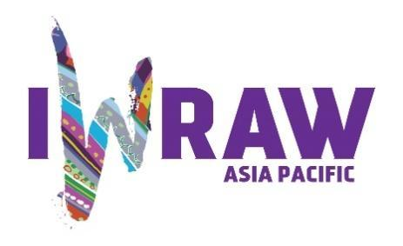

Questions for candidates to the UN Committee on the Elimination of Discrimination against Women (CEDAW Committee)
Please provide responses that are as precise as possible and in no more than 200 words per question.

1. Why do you want to be a member of the Committee on the Elimination of All Forms of Discrimination against Women? (video option)
I want to be a member of CEDAW in order to contribute from my expertise as a gender studies researcher and a feminist activist. Moving from the national to the international level is my dream, as I believe the international human rights bodies in general, and CEDAW in particular, are key to moving women’s right to equality forwards. International law is an educational tool, which motivates and inspires jurisdictions, through dialogue, norm-creation, and supervision. CEDAW has a special role in encouraging dialogue between relevant national stake-holders, as well as in developing shares language and basic norms for protecting women’s right and advancing gender equality. I believe this role is crucial so national bodies will not waste energy in inventing wheels that were already invented elsewhere, and for strengthening those who push for women’s equal rights in the face of the current backlash.

2. What are your specific areas of expertise in relation to CEDAW? Please provide examples as appropriate. (video option)
I believe I can contribute to CEDAW as a legal scholar and a sociologist who specializes in families and gender. My studies on active parenthood, parenthood upon divorce, religious and civil family court, transnational families and more, are highly relevant to the work of CEDAW. I am also a specialist in elder law, and as old age is highly gendered, both from the care-recipient and the care-provider sides, this is very relevant to the work of CEDAW. My studies on Israeli shelters for survivors of human trafficking, as well as my activist work with NGOs dedicated to end gender based violence, is also relevant to much of the work done by the Committee. Finally, my academic work on feminist male activists, and my experience as the Head of the Women and Gender Studies Program with male students, convinced me that CEDAW should strive to find ways to make men part of the conversation, and part of the solution. A striking example is paternity leave, which should become a parameter for gender equality like maternity leave is. More generally, as a socio-legal researcher, with rich experience in activism, I can push for reviews that emphasis evidence based policy making and that insist on implementation of law in action and not only law in the books.

3. What do you think are the most critical and emerging issues for women’s human rights and gender equality? Please provide 1-2 examples.
In my opinion, the most urgent and important task in the ongoing struggle for women’s right to equality is to guaranty women’s economic independence. Economic independence from State and family is the key for liberty and autonomy and for the ability to write one’s life story. Moreover, we know from studies that women’s economic independence is crucial for the thriving of their community. Discrimination in the education system and in the labour force, as well as discrimination against women as daughters and mothers, and at old age, are all obstacles to economic independence.
The second challenge, sadly becoming an urgent priority, is the current backlash against past achievements in the struggle for women’s equality. In different parts of the world, access to safe sex and abortion is restricted including in cases of rape and minority, mothers’ negotiation power upon divorce is weakening, and women’s exclusion from the public sphere increases rather than decreases.

4. How will you ensure that the rights and issues of the most marginalised groups of women are addressed by the Committee? What measures should States take to ensure the political participation of marginalised groups of women in political life, at the local, national and international levels, including enhancing representation within the CEDAW Committee?
The committee should make sure that shadow reports and testimonies of women who are part of marginalized groups are part of the review process, and strive for access to all to individual complaints. State should take active part in outreaching to women who are part of marginalized groups, providing them with leadership training, supporting their NGOs, and integrating their leaders in political life via reserved sits on local and national bodies. State should conduct roundtables with reserved sits to women who are part of marginalized groups as part of the preparation of the report to CEDAW and protect women who wish to testify in cases this might endanger them by securing confidentiality. State should also refrain from any retaliation against women and NGOs who submit critical shadow report.
5. What do you think are the areas where the Committee can further strengthen international women’s rights standards?
I would stress three areas: 1) Education for gender equality. That is not only equality in participation in the education system, but also educational content that incorporates the values embedded in CEDAW and the rights in guarantees as part of the curriculum – from kindergarten to high school. Education for gender equality from early age is key for an equal and just society for all. 2) Rights of elder women. In July 2021 the Independent Expert on the enjoyment of all human rights by older persons, Claudia Mahler, submitted her report on aging and gender. Her recommendation that old age become a systemic prism through which all rights are understood and all reports are reviews, should be implemented. 3) Encouraging men’s participation in the private sphere. While women around the world are increasingly participating in the public sphere, men are failing to take care responsibilities. Equality for women is dependent on shared care responsibilities and policies that encourage that should become standard. Moreover, I believe that such care socialization and involvement will reduce male violence.

6. What has been your experience of working with the women’s rights movement in your country or globally?
I have been a feminist activist for the last quarter of a century. Among other activities, for 10 years, I was a founding board member of Itach-Maaki (“With You” in Hebrew and Arabic) – female lawyers for social justice, which strives to bring legal achievements related to gender equality to underprivileged women. I was also a board member of the Israel Women’s Network, the leading lobby feminist NGO in Israel. For the last three years, I was a part of the Connecting for Impact project, as co-coordinator and advisor. This project brings together CEOs of feminist NGOs, to enhance their knowledge in gender studies, their managerial skills and the connections among them, in order to enhance the overall inpact of the Israeli feminist field. In addition, I devote time to public lectures, mainstream media appearances, and keyboard activism (mainly on Facebook) so to advance public awareness to the causes of the women’s right movement. Finally, as member and Head of the Gender Studies Program, I initiate and execute many events that brings together researchers and activists, so to promote ongoing dialog between academic and grassroots knowledge.
7. State parties to CEDAW are required to take steps to implement the Convention. How do you propose to help guide States in the effective implementation of Convention standards? How will you guide States in the removal of reservations to the Convention, especially reservations that relate to the object and purpose of the Convention (Articles 2 and 16)?
As mentioned above, I perceive compliance as the major challenge of treaty bodies, CEDAW included. I think the Committee should use dialogue and assertiveness to encourage and implantation of CEDAW standards and the removal of reservations. The dialogue should include intense discussions with all relevant stakeholders, which take the particular social, economic, political and legal circumstances of each state party into consideration. The aim should be a ten-year plan of gradual and realistic change. In addition, success stories from different jurisdictions should also be published on the Committee website and other media channels so to praise those state parties to put the effort needed to secure women’s rights, especially in the face of challenges, and to inspire and encourage other jurisdictions.
8. What can the Committee do to further strengthen its engagement with other stakeholders and accountability mechanisms at country level, including gender machinery, national human rights institutions (NHRIs), members of parliament, judicial actors, civil society organisations and UN agencies?
The Committee’s website was recently re-designed and it is now much more accessible and in line with the virtual language of other UN agencies. It is crucial this process will be continued, and that the website will be rich with data, inviting and accessible, and linked to UN Women and other gender related information and activities held by UN agencies and other treaty bodies. I believe a yearly thematic one-day conference, initiated by the Committee, and open to all via zoom, which will include one theoretical panel on debated topic, and three pragmatic panels with cutting edge relevant data, examples of best practices and success stories can significantly strengthen the Committee’s engagement with other stakeholders. Finally, as mentioned above, out-of-sessions meetings of individual Committee members with officials, NGOS, and leaders in the economic sectors, who are interested in pushing women’s right to equality forwards, can also contribute to the Committee’s ongoing and up-to-date engagement.

9. How do you see the CEDAW Committee strengthening the domestic and international environment for:
- holding business/private actors responsible for violations under the Convention?
I believe the Committee should address governments, and that its engagement with private actors should only be via voluntary dialogue, relevant data (on the positive impact of gender equality on business), and inspiring examples from companies that took upon themselves to promote women’s equality and succeeded.
- ensuring accountability of State parties while acting within the broader multilateral system, including the gendered impact of State action or inaction on global economic and financial matters, the climate crisis, and the COVID-19 pandemic; and
The Committee has published an important Note on Covid and its impact on women, and I am sure it will a lens through which reports will be examined. Likewise, the Committee already in 2018 addressed the impact of the climate crisis on women and published important recommendation (37), which should be followed.
- fortifying international cooperation on these and other urgent global matters?
See above

10. How do you see the CEDAW Committee and the review process contributing to the delivery of global commitments on gender equality, including under the 2030 Agenda for Sustainable Development?
See above

11. What role do you see civil society playing in the CEDAW State review process? Do you regularly engage with civil society in your current work? If so, how?
On the one hand, I know that shadow reports and discussions with civil society is crucial for the work of the committee. Without it, much might be left in the dark, and women voices and realities, from all social groups, might not be represented. On the other hand, my studies on Israeli fathers’ groups tactics, including false shadow reports to UN bodies, demonstrate the cautious UN bodies should take when relying on such reports. In our era, civil society related to gender does not only mean pro-women organizations, and might also mean misogynists NGOs. Hence, shadow reports should be carefully examined, including their source and the evidence they are based on, and governments should be granted the opportunity to response and clarify.

