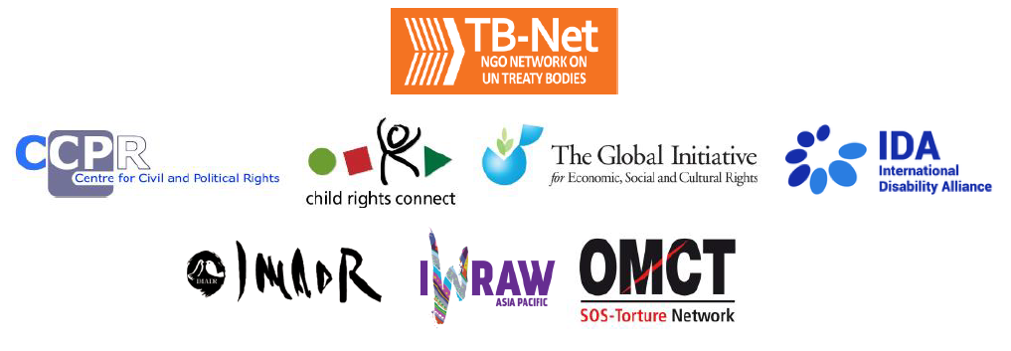

Elections 2022

Committee on the Rights of Persons with Disabilities (CRPD)

Committee on the Elimination of Discrimination Against Women (CEDAW)

Human Rights Committee (HRCttee)

Committee on the Rights of the Child (CRC)

Committee on Economic, Social and Cultural Rights (CESCR)

Subcommittee on Prevention of Torture (SPT)

Questionnaire for candidates
Six UN Treaty Bodies (Committee on the Rights of Persons with Disabilities (CRPD), Committee on the Elimination of Discrimination Against Women (CEDAW), Human Rights Committee (HRCttee), Committee on the Rights of the Child (CRC), Committee on Economic, Social and Cultural Rights (CESCR) and Subcommittee on Prevention of Torture (SPT)) will have elections organised in 2022.
In order to strengthen the treaty bodies, the International Disability Alliance, Child Rights Connect, IWRAW Asia Pacific, the Centre for Civil and Political Rights, and the Global Initiative For Economic, Social And Cultural Rights – as part of TB-Net, the NGO network on the UN Treaty Bodies – seek to promote quality, independence and diversity of treaty body membership through transparent and participatory nomination and elections processes.
This questionnaire, which is sent to all nominated candidates and is based on the criteria set forth in the relevant treaties and in the General Assembly Resolution 68/268, will enable all States and other stakeholders to better understand the skills, experiences and motivation of running candidates to CRPD, CEDAW, HRCttee, CRC and CESCR in advance of the elections.
The written responses to the questionnaires will be made available on the website www.untbelections.org, while the video responses will be shared on a dedicated YouTube page.
This initiative does not imply that we support or oppose any individual candidates.

Questions for all treaty bodies candidates

1. Name: Genoveva Tisheva

2. Nationality: Bulgarian

3. Current position: CEDAW Committee member, member of the working Group on communications, Chair of the WG on GBV AW

4. Are you currently holding, or have you previously held any position on behalf of, or for, your Government (Executive branch) that may compromise your actual or perceived independence and impartiality? If so, please give details:
No.
5. Please indicate any current or potential conflict of interest that may prevent you from exercising independence and impartiality in your work as a member of a UN treaty body:
N.A.
6. Was the nomination process for your candidacy a transparent and participatory process? Was civil society or other relevant stakeholders involved?
Yes.
7. During your possible mandate as a Committee member, what other positions or professional activities do you intend to engage in?
Director of the Bulgarian Gender Research Foundation, Director of the Women’s Human Rights Training Institute
8. The commitments as a Committee member are very time-consuming during and outside session time. How will you ensure to have the capacity to dedicate the necessary time to the work of the Committee, both in person and online?
My NGOs and programmes have dedicated staff and experts and my work there is more expert and advisory.

9. What are the current and main challenges that you see for the treaty body system and what are your ideas for improvement?
The Treaty body system was impacted by all crises in the last years, including the pandemic of COVID- 19, the effect of the backlash challenging human rights, the financial difficulties of the system.
Efforts from all sides are needed- first from the states, then the UN and TB system as well, and also NGOs in order to support and strengthen the TBs.
The process of harmonization which started should continue, both procedurally and in substance, the awareness and education on human rights and on women’s rights have to go in parallel at national and regional levels.
10. Given the current situation of the COVID-19 pandemic worldwide and the disruption of in person meetings of treaty bodies, will you be willing to adapt to undertake online work during your mandate, as an increasing way of functioning of the Committees?
It is already a fact. I worked during my first mandate in both in- person and online format.

Link to your full resume:
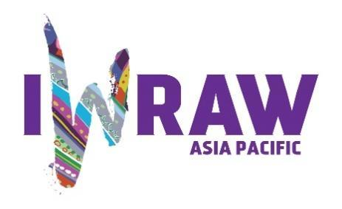
https://www.ohchr.org/en/events/events/2022/22nd-meeting-states-parties-2022-elections

Questions for candidates to the UN Committee on the Elimination of Discrimination against Women (CEDAW Committee)
Please provide responses that are as precise as possible and in no more than 200 words per question.

1. Why do you want to be a member of the Committee on the Elimination of All Forms of Discrimination against Women? (video option)
I firmly believe in the cause of equality of women and men, in women’s rights and further work on these issues is even more important now. All my professional work and as a lawyer in the last over 25 years now is related to human rights and women’s rights.
2. What are your specific areas of expertise in relation to CEDAW? Please provide examples as appropriate. (video option)
Gender- based violence against women, protection of women in vulnerable situations, economic empowerment of women, access to justice for women

3. What do you think are the most critical and emerging issues for women’s human rights and gender equality? Please provide 1-2 examples.
The different crises created emergency in many aspects of women’s rights- namely the exacerbation of violence in all its forms, including harmful practices, and emerging ones, like online violence. In parallel, the pace of equality in employment and economic and political decision- making is still slow. And yet the harmful impact of backlash ideology spread all over the world and which questions already achieved standards and makes obstacle to progressive realization of rights and endangering the achievement of SDGs.
4. How will you ensure that the rights and issues of the most marginalised groups of women are addressed by the Committee? What measures should States take to ensure the political participation of marginalised groups of women in political life, at the local, national and international levels, including enhancing representation within the CEDAW Committee?
The work of the CEDAW Committee is very much focused on the rights of most vulnerable groups of women and girls and this is one of my focus areas. Following the Convention, the working methods of the Committee are aimed at the protection of all women in all situations. Therefore in the recommendations in the COBs the Committee recommends to SPs, according to the concrete situation, different measures for the most vulnerable groups of women, under the different articles of the Convention and essentially under Article 1 and 2, 3, and also 14, where, in addition, the rights of such women are addressed. Same in the GRs, like for ex. GR 28, 35 the situation of vulnerable groups is largely covered and specific measures are required by the SPs. Tailored recommendations are made in the COBs concerning access to justice, GBV AW, political participation, equality in employment, in access to education and health services, for example. In some instances even special temporary measures are recommended, according to Article 4 of CEDAW.
5. What do you think are the areas where the Committee can further strengthen international women’s rights standards?
The current situation and the exiting from pandemic crisis require further enhancing monitoring and protection in all areas covered by the Convention. The situation of women in conflict and post- conflict requires further reaction of the UN system as a whole and the Committee already started responding to that through its working methods, working groups and task forces. The strengthening of the standards, the protection in all fields is mainly a question of protection and implementation by the SPs and the Committee can sharpen the monitoring of their action and urging the states even more to act adequately. After the pandemic, more interaction with states and CSOs is needed in reporting and follow- up, and the enhancement of the already started interaction with the other TBs.
Through the work under the OP CEDAW and the Views and recommendations in specific cases and situations the Committee contributes and will contribute further for strengthening of the international standards and protection of women.
6. What has been your experience of working with the women’s rights movement in your country or globally?
I started working for CSOs in the field of equality and women’s rights in the early 90ies as a part and leader of a NGO of women lawyers, then in NGOs with focus on research and education on human rights and women’s rights. I am still leading NGOs of women in the sphere of research, education and fight against GBV in my country. We are part of regional networks of women against violence, in networks with NGO, including international NGOs for women’s rights, socio- economic rights and development finance and also climate justice, with focus on gender justice.
My expertise also as a lawyer in the field of HR and women s rights was largely influenced by the knowledge gained and my commitment to the issue is also drawn from the direct work with my colleagues, nationally, regionally and globally. I have experience with the Bulgarian and international NGOs in parallel reporting before the CEDAW Committee, other TBs and under the UPR procedure.
Currently, my organization in Bulgaria – the BGRF is continuing the educational programme for lawyers in women’s rights- the Women’s Human Rights Training Institute which is a unique CSO initiative for young lawyers ( since 2004)who are taught on HR and women’s rights protection, including on CEDAW and its OP.
7. State parties to CEDAW are required to take steps to implement the Convention. How do you propose to help guide States in the effective implementation of Convention standards? How will you guide States in the removal of reservations to the Convention, especially reservations that relate to the object and purpose of the Convention (Articles 2 and 16)?
The Committee during the dialogues, in the COBs and during follow- up procedures proposes to the SPs support in the implementation of the Convention, like expert support, technical support , if needed and required. In addition, as mentioned here in the other responses, the Committee elaborates guidance for reporting for the SPs, for the implementation of specific aspects of the Convention. The pandemic made obstacle to in- person meetings and visits for this purpose but definitely regional expert meetings and such at national level will follow the lifting of the limitations related to the pandemic.
To mention the priority recommendations for each SP in the end of the COBs and the follow- up procedure for such issues that are at stake ad could be implemented in a 2- years period. It remains a very important method of work and will be further refined.
As to the removal of the reservations- the Committee pays special attention to this important issue and at each time of dialogue with such a SP it reminds about the review of their position. The final decision is up to the concrete SP, in which the role of national actors and civil society have an important impact.

8. What can the Committee do to further strengthen its engagement with other stakeholders and accountability mechanisms at country level, including gender machinery, national human rights institutions (NHRIs), members of parliament, judicial actors, civil society organisations and UN agencies?
The Committee pays special attention in the dialogue and the COBs to the role of these national bodies and institutions and each specific case. Under the first articles of the Convention reflecting the core obligations of the SPs the Committee always recommends appropriate measures for involvement of these institutions in the implementation of the Convention and the COBs but also in the process of setting standards at national level. Special attention goes to the NHRIs and the national machinery for gender equality, where the Committee always asks for concrete measures for more human resources, technical resources and financial resources for these bodies.
The Committee can hear the NHRIs in special sessions in preparation for the dialogues and has elaborated guidelines for the interaction with these institutions.
9. How do you see the CEDAW Committee strengthening the domestic and international environment for:

(a) holding business/private actors responsible for violations under the Convention?

(b) ensuring accountability of State parties while acting within the broader multilateral system, including the gendered impact of State action or inaction on global economic and financial matters, the climate crisis, and the COVID-19 pandemic; and

(c) fortifying international cooperation on these and other urgent global matters?
The role of the Committee in these three fields is related to strengthening of the monitoring and guidance to SPs during the dialogues mainly and during the follow- up procedures, by targeting, where appropriate in the concrete situation, these issues. For example, in the case of a/, through both State obligations and due diligence, the respective state should be held responsible for not observing equality of women by these enterprises in the respective field and covered by the Convention. They can be recommended to take action with respect to these cases, in terms of legislation, policies, supervising mechanisms. In the same time, In the review of states with companies responsible for WR violations abroad, there is possibility for monitoring of their obligations as well. It all depends on the concrete case.
In cases of b/ , based also on other international obligations and agendas, the respective SPs will be reminded about their responsibilities, eventual failures and actions to be taken within these frameworks, based on the scope and the coverage by the Convention.
Under c/ - in all cases SPs are reminded during the reviews and from the very beginning about their international obligations and in the frames of these- about international cooperation obligations related and with impact on gender equality and the rights of women.
10. How do you see the CEDAW Committee and the review process contributing to the delivery of global commitments on gender equality, including under the 2030 Agenda for Sustainable Development?
The Agenda 2030 and the SDGs are connected with all methods of work of the Committee. The dialogues with SPs and the COBs are largely based on the SDGs and a guidance for reporting to the Committee through the lenses of the implementation of the SDGs was published, as a result also of the work of a special WG for that. At each and every report of a SP, the state is reminded about that and asked about concrete plans and strategies related to that and their implementation.
11. What role do you see civil society playing in the CEDAW State review process? Do you regularly engage with civil society in your current work? If so, how?
The role of the civil society is decisive for the work of the Committee. Together with my colleagues we are involved in gathering all the information presented by CSOs for the dialogues and follow- up and through our other methods of work. We hope that the in- presence meetings with civil society will remain in the future as the most important source for us. The current still online briefings are very important but I will prefer resuming the meeting with NGOs, national and international.

