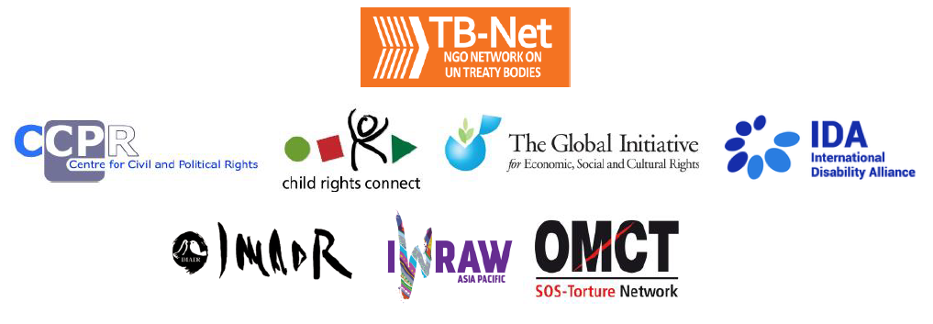

Elections 2022

Committee on the Rights of Persons with Disabilities (CRPD)

Committee on the Elimination of Discrimination Against Women (CEDAW)

Human Rights Committee (HRCttee)

Committee on the Rights of the Child (CRC)

Committee on Economic, Social and Cultural Rights (CESCR)

Subcommittee on Prevention of Torture (SPT)

Questionnaire for candidates
Six UN Treaty Bodies (Committee on the Rights of Persons with Disabilities (CRPD), Committee on the Elimination of Discrimination Against Women (CEDAW), Human Rights Committee (HRCttee), Committee on the Rights of the Child (CRC), Committee on Economic, Social and Cultural Rights (CESCR) and Subcommittee on Prevention of Torture (SPT)) will have elections organised in 2022.
In order to strengthen the treaty bodies, the International Disability Alliance, Child Rights Connect, IWRAW Asia Pacific, the Centre for Civil and Political Rights, and the Global Initiative For Economic, Social And Cultural Rights – as part of TB-Net, the NGO network on the UN Treaty Bodies – seek to promote quality, independence and diversity of treaty body membership through transparent and participatory nomination and elections processes.
This questionnaire, which is sent to all nominated candidates and is based on the criteria set forth in the relevant treaties and in the General Assembly Resolution 68/268, will enable all States and other stakeholders to better understand the skills, experiences and motivation of running candidates to CRPD, CEDAW, HRCttee, CRC and CESCR in advance of the elections.
The written responses to the questionnaires will be made available on the website www.untbelections.org, while the video responses will be shared on a dedicated YouTube page.
This initiative does not imply that we support or oppose any individual candidates.

Questions for all treaty bodies candidates

1. Name: Hiroko AKIZUKI

2. Nationality: Japanese

3. Current position: Member, CEDAW Committee
Professor, Asia University, Tokyo, Japan

4. Are you currently holding, or have you previously held any position on behalf of, or for, your Government (Executive branch) that may compromise your actual or perceived independence and impartiality? If so, please give details:
No.

5. Please indicate any current or potential conflict of interest that may prevent you from exercising independence and impartiality in your work as a member of a UN treaty body:
None.

6. Was the nomination process for your candidacy a transparent and participatory process? Was civil society or other relevant stakeholders involved?

I do not know. However, my nomination might have been consulted with the relevant stakeholders prior to the Government’s final decision.

7. During your possible mandate as a Committee member, what other positions or professional activities do you intend to engage in?

I will continue to be a Professor of Asia University.

8. The commitments as a Committee member are very time-consuming during and outside session time. How will you ensure to have the capacity to dedicate the necessary time to the work of the Committee, both in person and online?

My university provides full support for me to attend CEDAW Committee’s meetings both in person and online. My experience so far found that inter-sessional work can be manageable for me while teaching at the University.

9. What are the current and main challenges that you see for the treaty body system and what are your ideas for improvement?

Review cycle is not predictable for the State Parties and similar or duplicated questions are raised by different committees.
Predictable 8-year review cycle would be feasible for the most of committees, and concrete prioritization of issues for each committee and coordination among committees to avoid unnecessary duplication of questions would lead to reducing the reporting burden of the State Parties.

10. Given the current situation of the COVID-19 pandemic worldwide and the disruption of in person meetings of treaty bodies, will you be willing to adapt to undertake online work during your mandate, as an increasing way of functioning of the Committees?

Yes, of course.

Link to your full resume:
https://www.ohchr.org/en/events/events/2022/22nd-meeting-states-parties-2022-elections

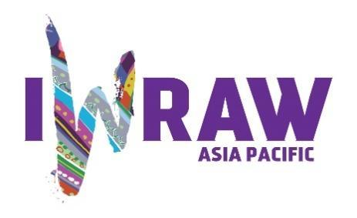

Questions for candidates to the UN Committee on the Elimination of Discrimination against Women (CEDAW Committee)
Please provide responses that are as precise as possible and in no more than 200 words per question.

1. Why do you want to be a member of the Committee on the Elimination of All Forms of Discrimination against Women?
Please see : https://www.youtube.com/watch?v=2Jowig39Zjk

The reason why I wish to become a member of CEDAW Committee is that it is have an urge for a world a place where every woman and girl can live their lives freely as they wish. Also, I would to know the reason why no country has yet attained gender equality even though more than forty years have passed since the CEDAW Convention came into effect, and think about the way to overcome those root causes of gender discrimination together with State Parties.

2. What are your specific areas of expertise in relation to CEDAW? Please provide examples as appropriate.
Please see : https://www.youtube.com/watch?v=2Jowig39Zjk

My specialty is international law and international human rights law. Monitoring domestic implementation of the CEDAW Convention by the State Parties is a matter of international law. Therefore, I can contribute to the work of the Committee in relation to finding out how the State Parties introduce the Convention into their domestic legal system, whether or not their legislations are in line with the Convention and other international human rights treaties, how far the Convention is applied in their domestic judicial system, whether or not their reservations are incompatible to the objectives and purposes of the Convention, and so forth.

3. What do you think are the most critical and emerging issues for women’s human rights and gender equality? Please provide 1-2 examples.

Most critical and emerging issue now is gender-based violence against women (GBVAW), especially sexual violence and domestic violence by intimate partners. It was quite obvious that the cases of GBVAW during the COVID-19 pandemic increased globally. CEDAW Committee has to respond, and actually is responding, to this critical issue promptly to fill the protection gap.
The fact that more than half of the violation cases of communication procedure, under the Optional Protocol of the CEDAW Convention, are the cases of GBVAW clearly shows that this issue is most critical one.
Another critical issue is gender stereotypes. No country has attained full gender equality, which means gender stereotypes exist everywhere. Gender stereotype is one of the root causes of gender discrimination with regard to the political and economic participation, decision-making, employment, education, reproductive health and rights, nationality, family relations and so forth. The next theme of general recommendation of the CEDAW Committee would be on gender stereotype, which clearly shows that it is the critical issue for the Committee.

4. How will you ensure that the rights and issues of the most marginalised groups of women are addressed by the Committee? What measures should States take to ensure the political participation of marginalised groups of women in political life, at the local, national and international levels, including enhancing representation within the CEDAW Committee?

I encourage the most marginalised groups of women to submit their alternative report at the time of constructive dialogue with the concerned State Party. It would be also preferable for them to participate in informal dialogues with the Committee either in-person or online. It is the opportunity for them to be heard directly by the members of the Committee.
I also encourage State Parties to introduce temporary special measures such as quota system to include the most marginalised groups of women to ensure their participation in political life.

5. What do you think are the areas where the Committee can further strengthen international women’s rights standards?

The Committee has been strengthening its work in the areas of gender-based violence against women through constructive dialogues with State Parties, by adopting general recommendations on GBVAW and adopting views of violation on GBVAW, despite there is no specific words as such in the CEDAW Convention. I think the Committee can further strengthen international women’s rights standards in this area.

6. What has been your experience of working with the women’s rights movement in your country or globally?

I have been reporting what were discussed in each session of the Committee, introducing views adopted on each communication cases, and asking for CSO’s alternative reports and for comments on issues, to the women’s rights movement in Japan, with a view to raise awareness on the CEDAW Convention and to increase visibility of the Committee.

7. State parties to CEDAW are required to take steps to implement the Convention. How do you propose to help guide States in the effective implementation of Convention standards? How will you guide States in the removal of reservations to the Convention, especially reservations that relate to the object and purpose of the Convention (Articles 2 and 16)?

I usually stress three important points of the Convention; first, the State Parties have to attain de facto equality between women and men; secondly, temporary special measures to attain de facto equality should not be regarded as reverse discrimination against men; thirdly, discrimination by private persons are also prohibited. Some of the State Parties do not understand these three points fully.
In order for the State Parties to implement the Convention fully, I encourage them to take gender disaggregated data to find out the reality of gender discrimination on the ground, and to evaluate the effect of their gender policy by measuring the progress made, to find out the areas left behind with no progress, and to make additional policy to fill those gaps. I try to provide concrete advise as much as possible.
With regards to the issue of reservations, I usually encourage the State Parties to learn from good practices of the experience of other State Parties in the same region, which have removed their reservations.

8. What can the Committee do to further strengthen its engagement with other stakeholders and accountability mechanisms at country level, including gender machinery, national human rights institutions (NHRIs), members of parliament, judicial actors, civil society organisations and UN agencies?

In order to further strengthen its engagement with other stakeholders, the Committee can provide technical assistance to the national machinery, national human rights institutions (NHRIs), members of parliament, judicial actors, civil society organisations through mock sessions of constructive dialogues or webinars on the Convention or women’s rights issues.

9. How do you see the CEDAW Committee strengthening the domestic and international environment for:

(a) holding business/private actors responsible for violations under the Convention?

This is one of the area the Committee should further strengthen. As I wrote in the question No. 7 above, gender discrimination by private persons including business firms should be prohibited and this should be fully understood by private actors.

(b) ensuring accountability of State parties while acting within the broader multilateral system, including the gendered impact of State action or inaction on global economic and financial matters, the climate crisis, and the COVID-19 pandemic; and

The Committee is doing its best to ensure accountability of State Parties in the broader multilateral system, by asking questions, during constructive dialogues, with regard to global economic and financial matters, the climate crisis, and the COVID-19 pandemic.

(c) fortifying international cooperation on these and other urgent global matters?

The Committee would need to fortify international cooperation in these areas by providing opportunities such as webinars or interactive dialogues for awareness raising and for identifying possible cooperation among concerned stakeholders.

10. How do you see the CEDAW Committee and the review process contributing to the delivery of global commitments on gender equality, including under the 2030 Agenda for Sustainable Development?

The CEDAW Committee and its review process are surely contributing to the delivery of global commitments on gender equality, including under the 2030 Agenda for Sustainable Development. Follow-up reports of the State Parties clearly indicate progress made by them, if not all of them.

11. What role do you see civil society playing in the CEDAW State review process? Do you regularly engage with civil society in your current work? If so, how?

Civil Society Organizations are taking pivotal role in the CEDAW Committee’s State review process. Their alternative reports are inevitable source for the Committee to know the reality of situation on the ground. Civil Society Organizations also raise awareness of the vulnerable groups of women on the Convention and encourage them to participate in the review process.
Yes, I regularly engage with Japanese civil society by regularly report on the Committee’s work on each session and write articles to raise awareness on the Convention and the Committee.

