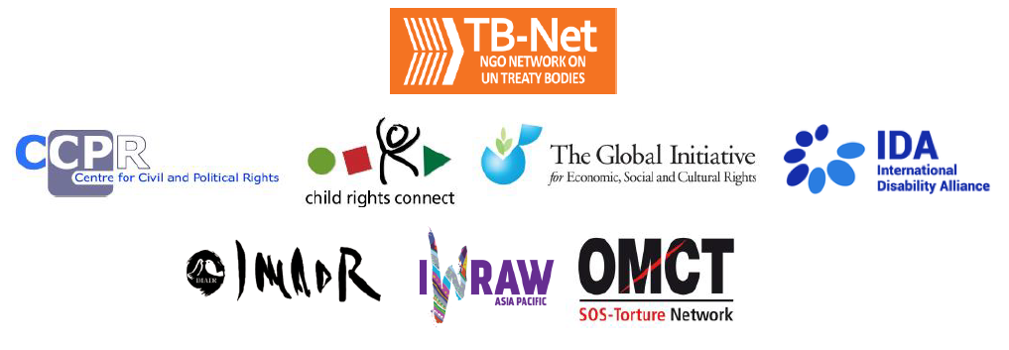

Elections 2022

Committee on the Rights of Persons with Disabilities (CRPD)

Committee on the Elimination of Discrimination Against Women (CEDAW)

Human Rights Committee (HRCttee)

Committee on the Rights of the Child (CRC)

Committee on Economic, Social and Cultural Rights (CESCR)

Subcommittee on Prevention of Torture (SPT)

Questionnaire for candidates
Six UN Treaty Bodies (Committee on the Rights of Persons with Disabilities (CRPD), Committee on the Elimination of Discrimination Against Women (CEDAW), Human Rights Committee (HRCttee), Committee on the Rights of the Child (CRC), Committee on Economic, Social and Cultural Rights (CESCR) and Subcommittee on Prevention of Torture (SPT)) will have elections organised in 2022.
In order to strengthen the treaty bodies, the International Disability Alliance, Child Rights Connect, IWRAW Asia Pacific, the Centre for Civil and Political Rights, and the Global Initiative For Economic, Social And Cultural Rights – as part of TB-Net, the NGO network on the UN Treaty Bodies – seek to promote quality, independence and diversity of treaty body membership through transparent and participatory nomination and elections processes.
This questionnaire, which is sent to all nominated candidates and is based on the criteria set forth in the relevant treaties and in the General Assembly Resolution 68/268, will enable all States and other stakeholders to better understand the skills, experiences and motivation of running candidates to CRPD, CEDAW, HRCttee, CRC and CESCR in advance of the elections.
The written responses to the questionnaires will be made available on the website www.untbelections.org, while the video responses will be shared on a dedicated YouTube page.
This initiative does not imply that we support or oppose any individual candidates.

Questions for all treaty bodies candidates

1. Name: Rhoda Reddock

2. Nationality: The Republic of Trinidad and Tobago

3. Current position: Professor Emerita, Gender, Social Change and Development, The University of the West Indies, St. Augustine Campus, Trinidad and Tobago

4. Are you currently holding, or have you previously held any position on behalf of, or for, your Government (Executive branch) that may compromise your actual or perceived independence and impartiality? If so, please give details:
No I have not

5. Please indicate any current or potential conflict of interest that may prevent you from exercising independence and impartiality in your work as a member of a UN treaty body:
None of which I am aware
6. Was the nomination process for your candidacy a transparent and participatory process? Was civil society or other relevant stakeholders involved?
Civil Society groups recommended my initial nomination, I only learnt this later. For this re-election they are in agreement.

7. During your possible mandate as a Committee member, what other positions or professional activities do you intend to engage in?
- I am no longer engaged in full time salaried employment
- I will continue working on two books one on race and intersectionality in my country and the other drawn from research on Child Sexual abuse from a gender perspective;
- I will continue my membership and activism in one women’s organisation
- I will continue to be on the Board of the Coalition Against Domestic Violence of Trinidad and Tobago
- I will continue to be on the Executive Council of the International Sociological Association.

8. The commitments as a Committee member are very time-consuming during and outside session time. How will you ensure to have the capacity to dedicate the necessary time to the work of the Committee, both in person and online?
This is very true, I plan to complete work on these two books as by the end of 2023 and to reduce my commitments to at least one of these organisations.
9. What are the current and main challenges that you see for the treaty body system and what are your ideas for improvement?
The main challenges that I see are as follows:
- The need to strengthen of the follow-up procedure
- The lack of visibility of CEDAW and the important work that we do. Regional media in particular need to be sensitised to the work of CEDAW and the other treaty bodies and to follow and report on their work. This includes both mainstream and new media.
10. Given the current situation of the COVID-19 pandemic worldwide and the disruption of in person meetings of treaty bodies, will you be willing to adapt to undertake online work during your mandate, as an increasing way of functioning of the Committees?
During the height of the pandemic, the CEDAW Committee worked virtually for over one year continuing most of its responsibilities e.g. communications, inquiries, work on general recommendations, meetings/briefings with interest groups, pre-sessional working groups etc. This was difficult for many reasons including the time differences. For some members meetings began at 11.00/12.00 p.m. or 5.00 a.m. and technical capacity was unequal. As a result, meetings had to be shorter and this affected the depth and quality of the work that we had to do.
If circumstances require I am willing to adapt however, based on this experience, we feel that a great deal is lost in this process.

Link to your full resume:
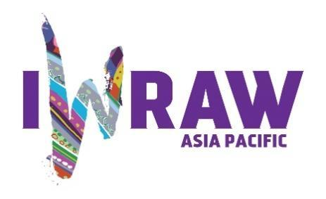

Questions for candidates to the UN Committee on the Elimination of Discrimination against Women (CEDAW Committee)
Please provide responses that are as precise as possible and in no more than 200 words per question.

- Why do you want to be a member of the Committee on the Elimination of All Forms of Discrimination against Women? (video option)

[If possible my video presentation will come later]

As someone who has taught, researched and been an activist in this field for many years, being a member of CEDAW provided me with new opportunities to use the acquired expertise and experience. It also allowed me to learn new skills and to expand my expertise in ways that I had not done before. It is very intense work with much sacrifice but it is a privilege to serve and to have the possibility to influence the lives of women and girls throughout the world.

During my first term, I understand that I was able to make many innovative contributions to the Committee’s work. With the experience of the first term and a deeper understanding of the workings of the organisation, a second term will allow me to consolidate and deepen this contribution,

2. What are your specific areas of expertise in relation to CEDAW? Please provide examples as appropriate. (video option)
[If possible my video presentation will come later]

My expertise is broad because of training in sociology, development studies and women’s and gender studies and my activist work in the women’s movement. I am able to address many areas if the Convention, including those related to access to justice, education, employment, economics, rural and disadvantaged groups of women, marriage and family, gender ideologies and stereotypes.

As a social and feminist theorist, I am able to think conceptually which allowed me to expand the notions that have been used in the past and to expand the thinking that shapes the work of the Committee.

- What do you think are the most critical and emerging issues for women’s human rights and gender equality? Please provide 1-2 examples.

- The backlash against the women’s movement and the authoritarian and conservative trends emerging globally.
- The economic impact on women of Covid-!9 which exacerbated the already precarious economic situation of women and girls
- The continued prevalence of violence against women in diverse contexts and situations.

4. How will you ensure that the rights and issues of the most marginalised groups of women are addressed by the Committee? What measures should States take to ensure the political participation of marginalised groups of women in political life, at the local, national and international levels, including enhancing representation within the CEDAW Committee?
In my current term on the committee, I have often asked questions related to article 14 on rural women and disadvantaged groups of women. In this, I have focussed on issues not traditionally addressed e.g. stigmatised and racialized minorities, the continuing enslaved, Indigenous women etc.
In relation to article 7 and 8, we have expanded the questions asked e.g. in relation to women in Public life and in diplomatic postings by asking about diversity in appointments and on political slates. The Committee recently agreed to develop a general recommendation on Women in Political Leadership this will be another opportunity to specifically express these issues.
One of my key concerns mentioned above is expanding the reach and visibility of the Committee. By making CEDAW more known globally and more deeply within all societies would be important in this regard. Additionally making participation in this and other treaty bodies more accessible would be critical in ensuring that women with disabilities can participate.
Another issue is that of language where with the reduction in funding to the Committee the translation in non-UN languages is limited. This affects the diversity of Committee membership and participation.

5. What do you think are the areas where the Committee can further strengthen international women’s rights standards?
One important area has to be the transformation of attitudes and belief systems. I feel that behaviour change also requires an understanding of the structures of patriarchy and inequality and the intersectional connections with issues of class, race/ethnicity, nationality, sex/gender identity etc. In my own work related to article 5, I have sought to expand the issues surrounding gender ideologies and stereotypes and the mechanisms to address these through education curricula, consciousness-raising, transforming oppressive femininities and masculinities, legislation etc. I am happy therefore that the Committee has agreed to develop a general recommendation on stereotypes.

6. What has been your experience of working with the women’s rights movement in your country or globally?
I have been active in the Trinidad and Tobago, Caribbean and Global women’s movement for most of my life and continue to be active at local level. A select listing of this is provided:
- Founding member and first chair – Caribbean Association for Feminist Research and
Action (CAFRA) 1985
- International Advisor, The Global Fund for Women, 1991 and continuing.
- Past President of the Research Committee on Women and Society of the International Sociological Association (ISA) 1994-1998
- Founding Member, Caribbean Network on Masculinity Studies, Secretariat- University of Puerto Rico, Rio Piedras Campus, 1996
- Lead researcher of the action /research project – Breaking the Silence: Child Sexual Abuse and Implications for HIV (2008-2011), and the Break the Silence, end Child Sexual Abuse Campaign, addressing child sexual abuse from a gender perspective.
- Member of the editorial advisory group for the UNWOMEN Publication – Progress for the World’s Women 2016-2018
- Board Member – Coalition against Domestic Violence (CADV) Trinidad and Tobago (T&T) 2019 and continuing.
- Interim Deputy Chair – Caribbean Association for Feminist Research and Action T&T (CAFRATT). 2020 and continuing
- Involved in the introduction of the Institute for Gender and Development Studies at The University of the West Indies (Three campuses).

7. State parties to CEDAW are required to take steps to implement the Convention. How do you propose to help guide States in the effective implementation of Convention standards? How will you guide States in the removal of reservations to the Convention, especially reservations that relate to the object and purpose of the Convention (Articles 2 and 16)?
- Many states parties have acknowledged the challenges of implementation. As mentioned earlier our follow-up procedure needs to be strengthened and could include working more closely with UNWomen regionally to provide technical assistance in this regard.
- Additionally the concluding observations need to be more widely disseminated e.g. through local media houses so that the public could be informed and non-governmental organisations could better monitor implementation locally.
8. What can the Committee do to further strengthen its engagement with other stakeholders and accountability mechanisms at country level, including gender machinery, national human rights institutions (NHRIs), members of parliament, judicial actors, civil society organisations and UN agencies?
- Regional and local level initiatives would be important in this regard e.g. during this 40th Anniversary year. This is an opportunity to make stakeholders more aware of the contribution that CEDAW has made over its 40-year history toward fulfilling its mandate to women of the world. This could be achieved through:

  - A compilation of achievements resulting from CEDAW Dialogues
  - A review of the impact of Inquiry visits and reports
  - A compilation of CEDAW jurisprudence coming out of the Communications or individual complaints procedure
These could be presented in both written and video form

- In addition, CEDAW needs to strengthen it linkages with regional media houses. This could be achieved through regional media workshops organised through the secretariat and local/regional UN offices.
- Enhanced collaboration with UNWomen especially through its regional offices as well as headquarters.
- The CEDAW Secretariat needs to be strengthened to provide the support necessary for this to be achieved.

9. How do you see the CEDAW Committee strengthening the domestic and international environment for:

- holding business/private actors responsible for violations under the Convention?
- This is extremely important, as over the past 3-4 decades there has been increasing focus on the private sector and reductions in the power of many states. Relatedly much of work on women’s rights and social care, has been transferred from the state sector to the NGO/Civil Society sector understood by the international financial institutions as part of the private sector.
- This could be achieved in the short term through questions that emphasise states parties’ responsibility to monitor private sector violations, the introduction of relevant legislation and sensitising private sector bodies, cooperatives, trades unions and workers organisations on the Convention and its mandates,

(b) ensuring accountability of State parties while acting within the broader multilateral system, including the gendered impact of State action or inaction on global economic and financial matters, the climate crisis, and the COVID-19 pandemic; and
The Committee has already made progress in this regard. For example:
- The adoption of General Recommendation 37 (2018) on the gender-related dimensions of disaster risk reduction in the context of climate change. This guides questions and observations related to this which are addressed during the dialogue e.g. in relation to Article 13 and Article 14.
- The inclusion of new paragraphs on Covid 19 in all concluding observations as well as questions during dialogues and related concluding observations;
- The inclusion of broader questions related to global economic policy and local impacts in relation to Article 13, Article 14 and Article 10 where the social impacts on e.g. health, social services and education are often felt.
- Ensuring accountability would necessitate a strengthened follow-up procedure, deeper collaboration with local and regional media houses to keep the issues alive. Additionally support from the regional UNDP and UNWomen offices would be required in this regard.

- fortifying international cooperation on these and other urgent global matters?

- CEDAW through its Chair and task force committee chairs do operate globally collaborating with special rapporteurs and other OHCHR personnel, and representatives of other UN bodies e.g. in the EDVAW Committee. This could be improved and the current Task Force on Afghanistan is a good example of this. However clearer mechanisms are required. Most importantly, the CEDAW secretariat must be enhanced to allow it to provide the support to the Committee necessary to complete all of these tasks. As already mentioned earlier by the authors of this questionnaire, the workload of a CEDAW expert is already very heavy and time-consuming so expanded responsibilities would need additional administrative support.

10. How do you see the CEDAW Committee and the review process contributing to the delivery of global commitments on gender equality, including under the 2030 Agenda for Sustainable Development?
- The SDGs have been a central component of the review process and of CEDAW’s work. A standard paragraph is included in all COBS and a working group on the SDGs has been active in the Committee. The SDGs are addressed in questions on articles and in specific recommendations of the concluding observations to states parties. It would be very useful to study in-depth CEDAW’s contribution to the implementation of the 2030 Agenda.
- It’s important to note that CEDAW’s contribution is not limited to SDG 5 on Gender Equality but to each of the SDGs because of the comprehensive character of the CEDAW mandate and its evolving practice.

11. What role do you see civil society playing in the CEDAW State review process? Do you regularly engage with civil society in your current work? If so, how?

- The civil society contribution to the Committees work is critical. Our work would be meaningless without this contribution. In the Caribbean Community region however, NGO involvement is low compared with other regions. As a result, with the one other CARICOM colleague, we have been engaging with regional entities and ngos using social media, giving talks, webinars etc. to develop greater awareness. My membership on this Committee has allowed for increased awareness of the Convention and the work of the Committee in my country and region.

